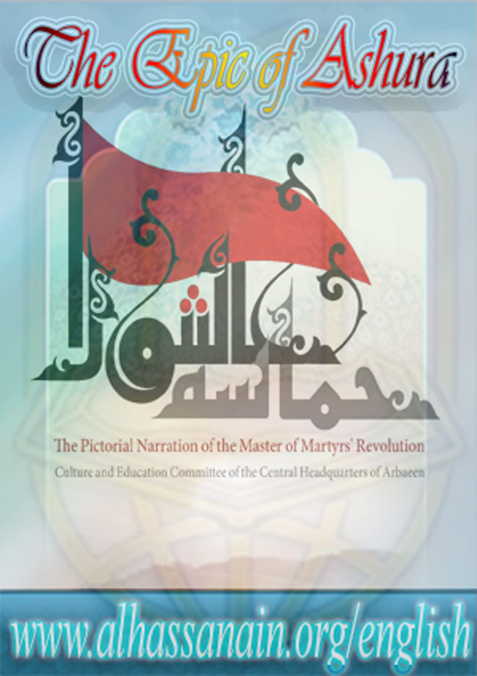

www.alhassanain.org/english



In the Name of Allah

The Epic of Ashura
Pictorial Narration of the Revolution of Sayyid al-Shohada

Translator: Abdoreza Bahrani
2017 – 1439



www.alhassanain.org/english

Notice:
This version is published on behalf of www.alhassanain.org/english
The composing errors are not corrected.

Table of Contents

[Preface] 7
The Start of Revolution 8
Demise of Mu’awiyah and Yazeed’s Letter to Medina’s governor 9
Imam Hussain (as) in the Court of Medina’s Governer 10
Imam Hussain (as)’s Conversation with Marwan ibn Hakam 12
Meeting with Muhammad ibn Hanafiyah 14
Imam Hussain's Departure from Medina at Night 16
Imam Hussain (as)’s Arrival in Mecca 18
People of Kufa’s Letters to Imam (AS) 20
Dispatch of Moslim to Kufa 22
Imam Hussain (as)’s sermon in Mecca 24
Zobalah 26
Muhammad ibn Ash’ath’s envoy comes to Imam (as) 26
Receiving the news of the martyrdom of Abdullah ibn Buqhtor 26
Baidhah 28
Nainawa 30
Nainawa 31
Amir al-Mumineen’s Prophecy Came True 33
Setting up the Tents 35
Arrival of Umar ibn Sa’d in Karbala 37
Kufan’s Dispatch to Fight Imam Hussain (as) 39
The Order of Forbidding the Water for Imam Hussain (as)’s Caravan 41
Umar ibn Sa’d Meets with Imam Hussain (as) 43
Abbas ibn Ali (as) Brings Water 45
Shimr ibn Dhil Jawshan Comes to Karbala with Ibn Ziyad’s Letter 47
Imam Hussain (as) Asking for a Respite 49
Imam’s Speech with His Companions on the Night of Ashura 51
The Day of Ashura 53
The Supplication of Imam Hussain (as) in the Morning of Ashura 54
Hurr ibn Yazeed Riyahi Joins the Army of Imam Hussain (as) 56
The Commencement of the Battle 58
The First Group Attack 58
The Second Attack of Umar ibn Sa’d’s Army 58
The Third Attack 60
The Noon Prayer of Ashura 62
Martyrdom of Jawn, the Retainer of Abu Dharr Ghifari 64
Fight and Martyrdom of Ali Akbar (as) 66
Martyrdom of Qasim ibn Hassan (as) 68
Imam Hussain (as) with the Moon of Bani Hashim Go toward Euphrates 70
The Fight and the Martyrdom of Abbas (as) 72
The fight and the martyrdom of Imam Hussain (as) 74
The Martyrdom of the Infant of Imam Hussain (as) 76
Imam (as) Starts the Battle and Asks for Help 78
Martyrdom of Abdullah ibn Hassan (as) 80
Martyrdom of Imam Hussain (as) 82

[Preface]
The magnificent ceremoney of Arbaeen is an everlasting tradition and the lasting heritage of Ahlul Bayt (as) in protecting and promoting the message of the great revolution of Ashura.In order to honor, preach and elucidate this great and magnificent tradition, the Cultural and Educational Committee of Iran's Central Headquarter of Arbaeen has found it necessary to explain its intellectual and historical backgrounds.
For achieving this goal, this committee has produced a special content in different forms including this text which is adapted from the book “the hisory of the revolution and the comprehensive maqtal of Sayyid alShohada (as)” and has illustrated the events that were involved in Imam Hussain (as)'s revolution from Medina to Karbala. And due to the rich content of this work the English Workgroup of the Committee found it useful to translate this work into English. And here we extend our gratitude to the respected scholar, Hujjatul Islam Abdoreza Bahrani, for the translation.

Cultural and Educational Committee
The Central Headquarters of Arbaeen

The Start of Revolution

Demise of Mu’awiyah and Yazeed’s Letter to Medina’s governor
After 19 years of ruling, Mu’awiyah died in Damascus at the age of 78 in 60 A.H and Yazeed came to rule.
Yazeed in a letter to Walid ibn Utba ibn Abi Sofyan, the governor of Medina ordered him to ask Imam Hussain (as)’s pledge of allegiance in favor of Yazeed. “When my letter reaches you, summon Hussain ibn Ali (as) and take his pledge of allegiance for me. If he refused, severe his head and send it to me”, he wrote.

Imam Hussain (as) in the Court of Medina’s Governer
When Walid ibn Utba got Yazeed’s letter and read it, he said, “Verily We are from Allah, and to Him do we indeed return. I have nothing to do with Hussain (as).” Then he sent some one to Marwan ibn Hakam to seek his counsel. After reading the letter, Marwan told Walid, “Before Hussain ibn Ali (as) knows about Mu’awiyah’s death, take his pledge of allegiance for Yazeed. If he did that, accept it from him and leave him. But if he refused, you should severe his head. However, I know that Hussain ibn Ali (as) will never pledge his allegiance to Yazeed.” Walid’s envoy went to Imam Hussain (as) and summoned him to Walid’s court. His eminence felt unsafe about this matter. Therefore he went to the court with thirty of Bani Hashimite youth and told them that he thought they’d oblige him to do something he didn’t like. Then he said, “If you heard me raised my voice, rush your way in to prevent him”. Imam Hussain (as) entered the court. Walid read him Yazeed’s letter and asked him to pay allegiance to Yazeed. Imam (AS) said to Walid, “O Amir, we are the household of the Prophethood, the treasure of the Messengerhood, and frequently visited by the angels, God has started with us and has finished with us. But Yazeed is a sinner, wine imbiber, the murderer of innocent people and the one who commits sins openly. But let us spend tonight [considering] and see which of us deserves more for the Caliphate and allegiance.” Then he left there and went home accompanied by his companions.

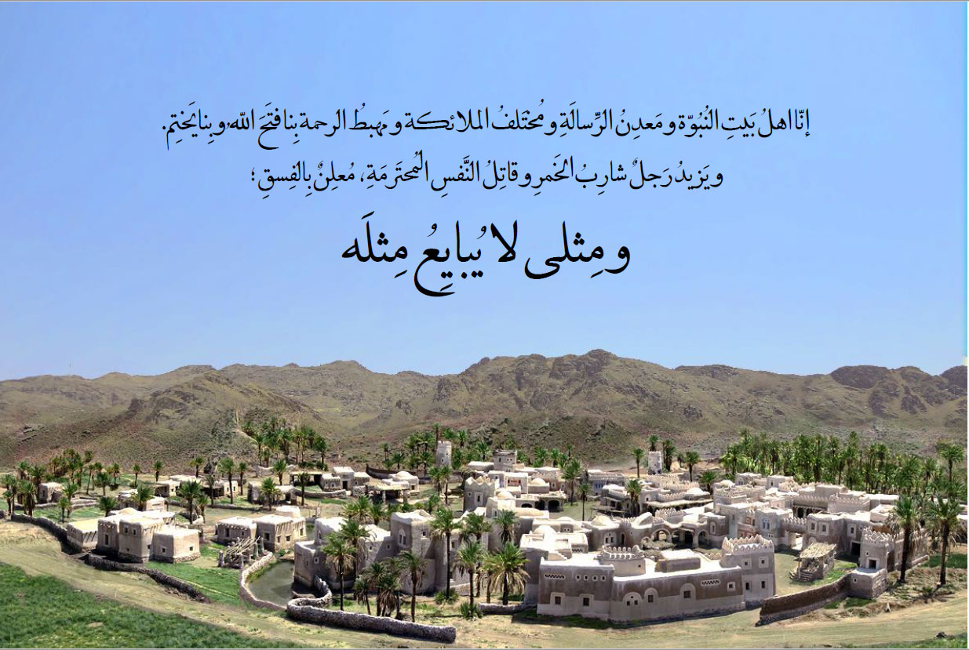

Imam Hussain (as)’s Conversation with Marwan ibn Hakam
When Imam Hussain (as) left his home the next day saw Marwan. Marwan said, “O Aba Abdillah! I am your well-wisher and recommend you to pay allegiance to Yazeed, since this work benefits your religion and your world.”
Imam (as) said, “Verily, we are from Allah, and to him do we indeed return. When the nation is afflicted with a ruler like Yazeed, then we should say goodbye to Islam.
Woe to you! You say that I must pay allegiance to Yazeed whereas he is a sinner. You are so wrong, O the owner of the great errors and flaws!
But I don’t rebuke you; because the messenger of Allah (S) cursed you when you were in your father, Hakam ibn al-As’s loin. And it is not expected from some one upon whom the Prophet’s curse is to say anything other than inviting to Yazeed’s allegiance.
I heard the Messenger of Allah (S) saying, ‘Caliphate is prohibited for the progeny of Abu Sofyan. When you see Mu’awiyah on my pulpit, you will have to tear his abdomen apart.’ But by Allah, when the people of Medina saw Mu’awiyah on my grandfather’s pulpit, didn’t obey the Prophet’s instruction. And thus Allah the Almighty afflicted them with Yazeed.”

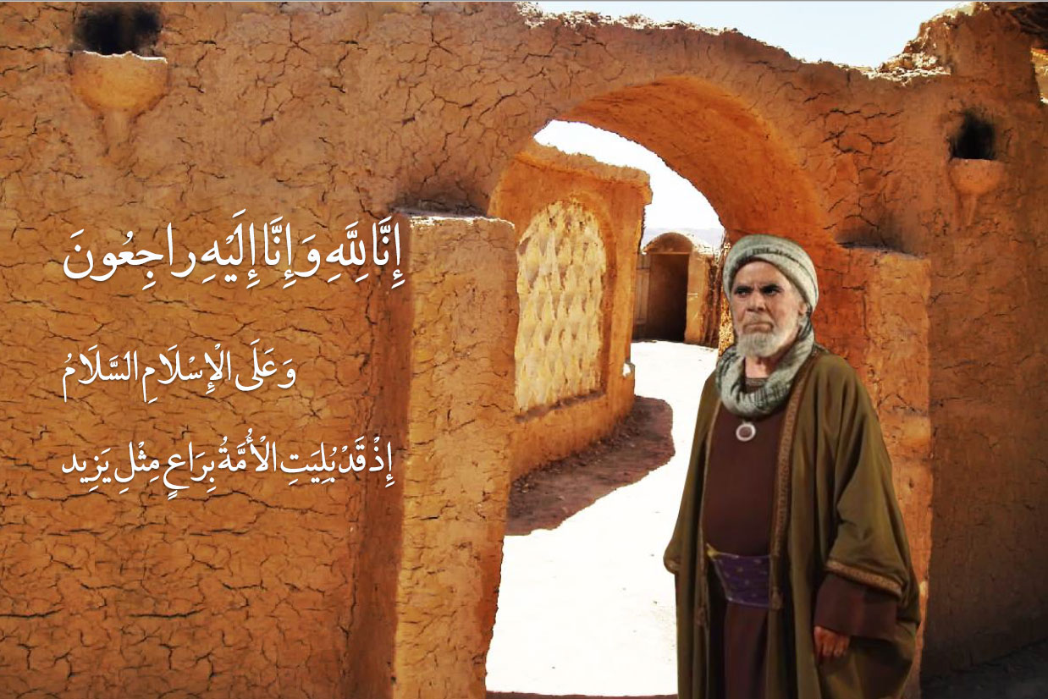

Meeting with Muhammad ibn Hanafiyah
Imam Hussain (as) is ready to leave Medina and proceed toward Mecca. Muhammad ibn Hanafiyah was informed about the decision of his eminence for leaving Medina and went to him. Imam (as) wrote his historic testament and handed it to Muhammad. The testament reads:
Bismillah al-Rahman al-Rahim
This is Hussain ibn Ali’s last will to his brother Muhammad known as ibn Hanafiyah. Hussain ibn Ali testifies to the oneness of Allah and bears witness that Muhammad is His servant and messenger and testifies that the hell is true and that the resurrection day will, without a doubt, happen.
I haven’t started the revolution out of debauchery, selfishness, corruption or oppression; rather my aim is to reform my grandfather’s nation and to conduct the way my father Ali ibn Abi Talib did.
Therefore, whoever accepts this truth and fact has indeed accepted Allah’s path and whoever refuses I will continue my way with patience and perseverance till Allah will adjudicate between me and these people.

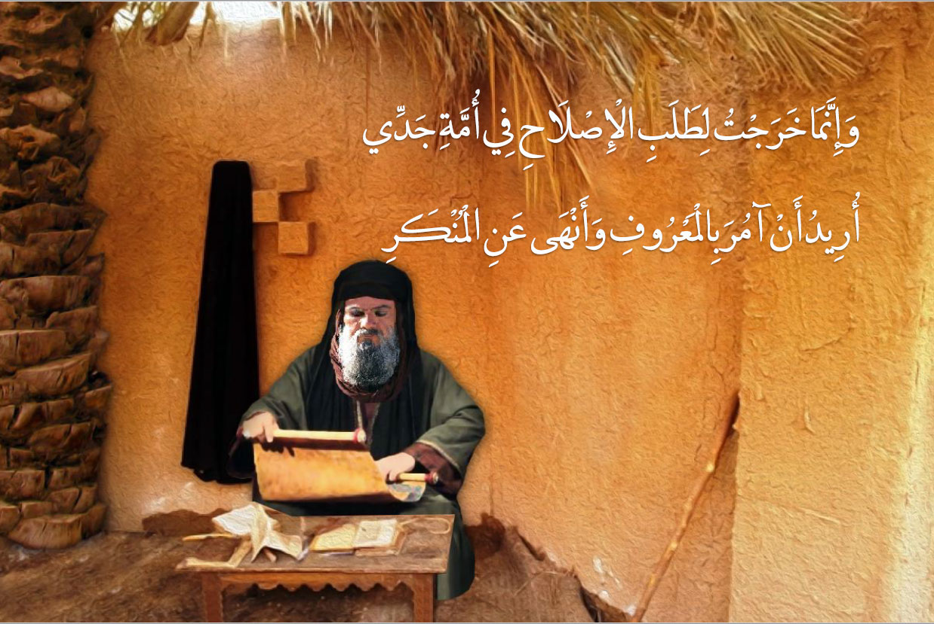

Imam Hussain's Departure from Medina at Night
At the night of Rajab 28, 60 A.H., Imam Hussain (as) departed from Medina with a group of Bani Hashim whose number were 21 and set out for Mecca.
When Imam (as) departed from Medina recited the following verse:
So he (Moses) left the city, fearful and vigilant. He said, ‘My Lord! Deliver me from the wrongdoing lot.’
Contrary to what Abdullah ibn Zubair did, Imam Hussain (as) took the main road from Medina to Mecca.

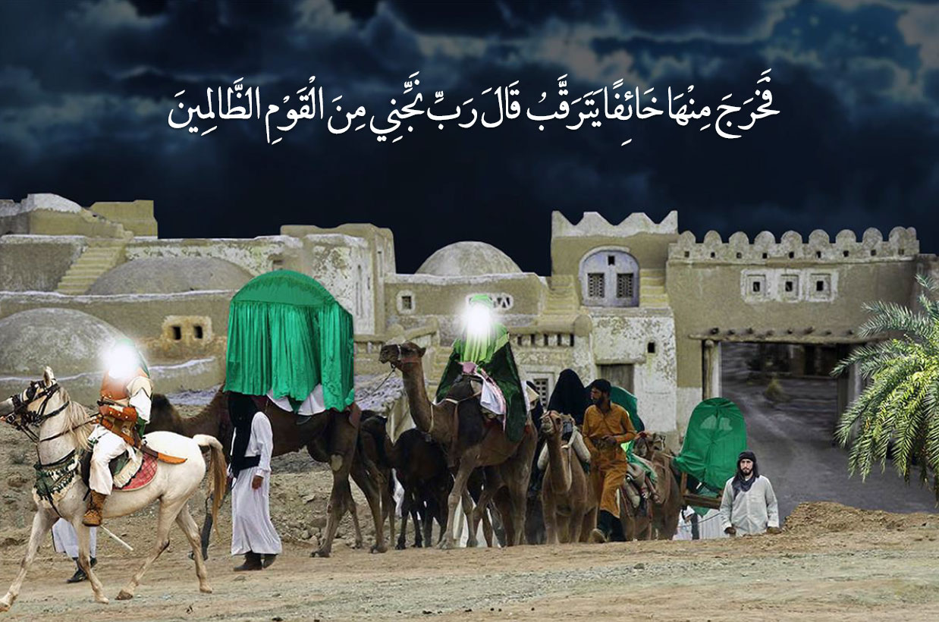

Imam Hussain (as)’s Arrival in Mecca
Imam Hussain (as) arrived in Mecca on the 3rd of Sha’ban in the year 60 after Hijrah. Invited by Abdullah ibn Abbas, Imam (as) inhabited his house known as Darul Abbas.
Imam’s staying in Mecca lasted for four months, a period which constitutes the major part of his cause and movement.
Imam’s choosing of Mecca was a wise decision; because Mecca was the secure Haram of Allah and the possibility of enemy’s harassment was very little. On the other hand, Imam’s entrance to Mecca, was at the verge of Hajj pilgrimage and hence Mecca was the gathering place for the Muslims from around the Islamic territory and the best spot to deliver his message to the public.
With Imam’s arrival in Mecca, the people went to him in groups.
Performing congregational prayers was one of the programs of his eminence in Mecca.

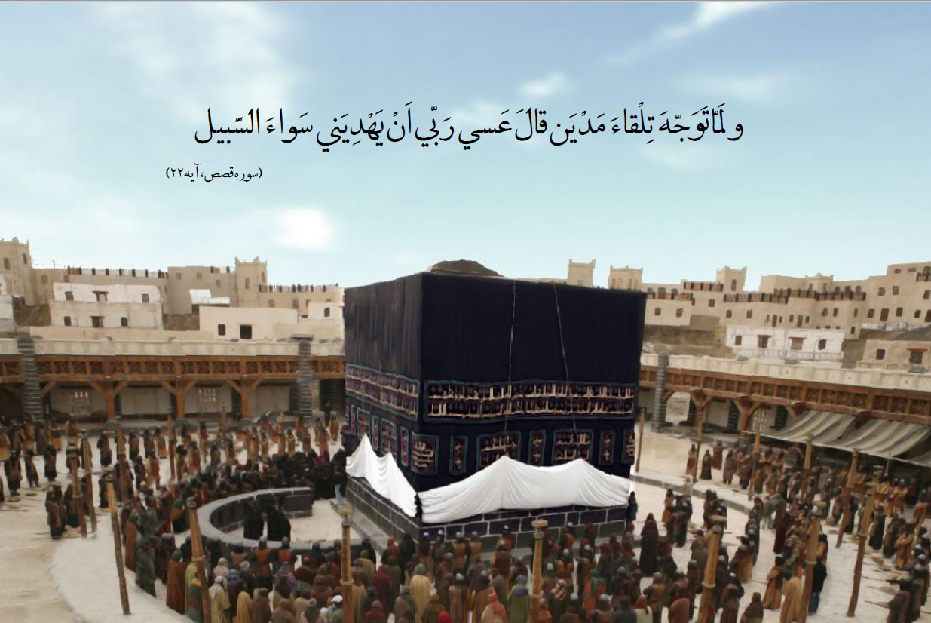

People of Kufa’s Letters to Imam (AS)
When the Shia of Kufa knew about Mu’awiyah’s death, they gathered at the house of Soleyman ibn Sorad al-Khuza’ei. Soleyman, one of the great Shia figures in Kufa, said to the Kufans:
You are the Shias of Hussain ibn Ali and his father (as). If you are certain that you will assist and support him and will fight his enemies write letters to him. But if you fear lest you would turn sluggish and retreat, then do not betray him [by inviting him here].
At this moment, all of them said unanimously: No, Of course we will fight his enemies under his command and offer our lives alongside him. Then the Kufans started writing letters with this theme:
In the name of Allah, the Compassionate, the Merciful. From the believing Shias and followers of Hussain ibn Ali (as) to his holiness. Make haste! Because the people are awaiting you and neglect anyone but you. Hasten! Hasten! Again hasten, hasten! And Peace be upon you.
Dispatch of 150 letters with 12 thousand signatures left no excuse for Imam (as).

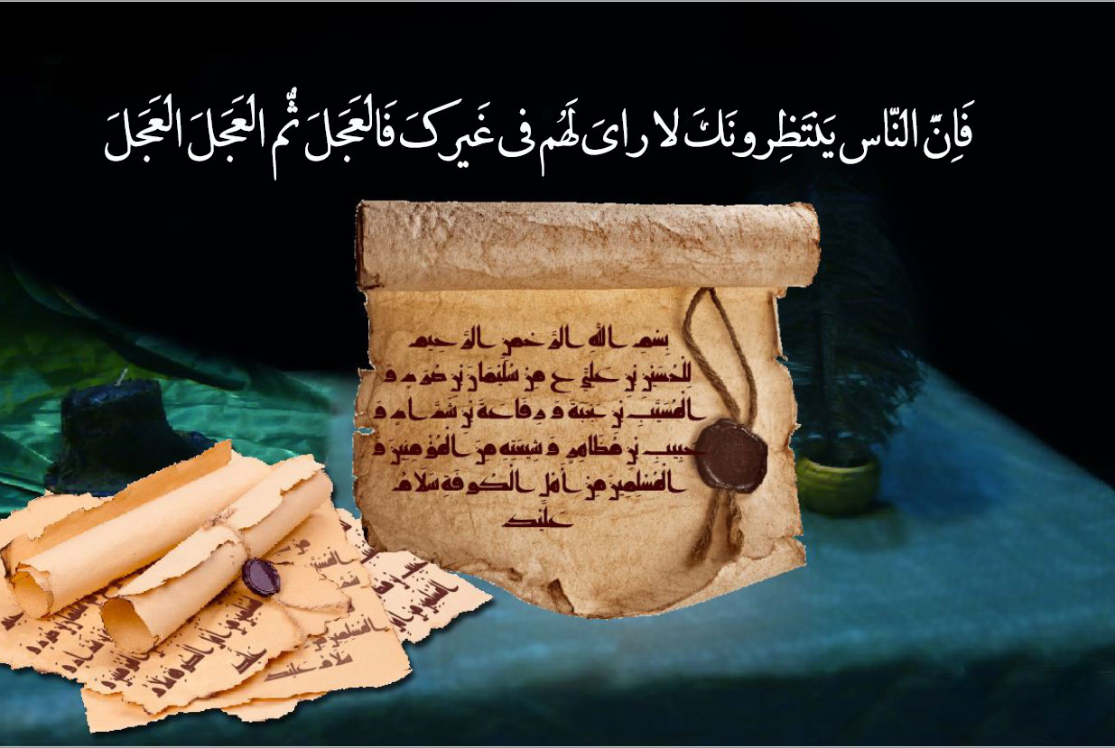

Dispatch of Moslim to Kufa
The people of Kufa’s ill-fame and Imam’s knowledge of them, compelled him to first make sure whether these invitations were as a result of sincerity and cognition. Hence Imam (as) selected his trusted one, Moslim ibn Aqeel as his representative and envoy and wrote a letter to the Kufans:
Now then, I sent to you my cousin, my brother and a trustworthy person from among my family, Moslim ibn Aqeel, and I have instructed him to inquire about your affairs and write to me regarding it.
If he writes to me that you hold the same opinion as what is written in your letters, then I shall come to you quickly, Allah willing.
Moslim ibn Aqeel departed from Mecca in mid Ramadan and arrived in Kufa on 5th of Shawal.

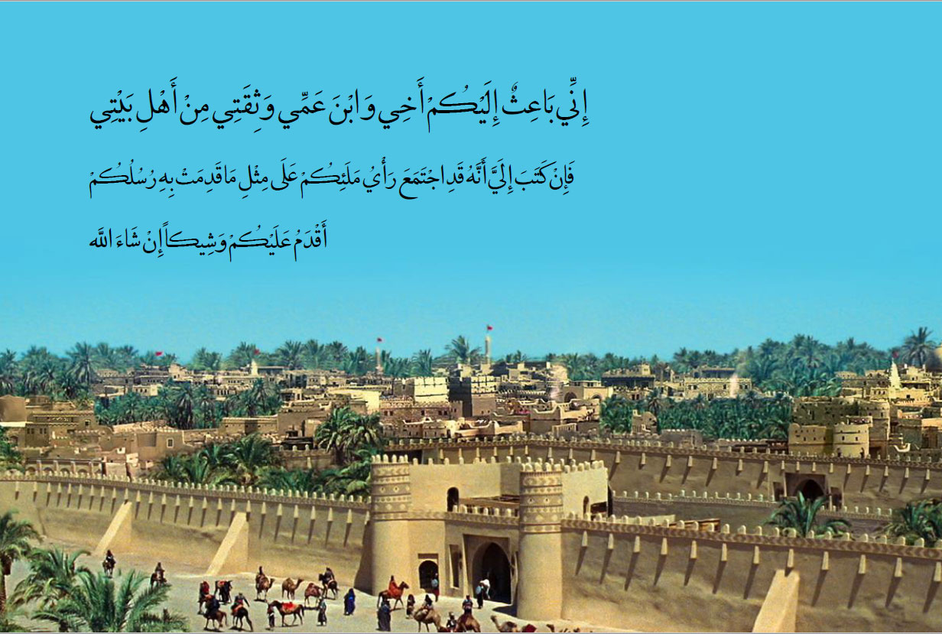

Imam Hussain (as)’s sermon in Mecca
Before leaving Mecca and proceeding toward Iraq, Imam Hussain (as) delivered a sermon in which he announced his leaving. After praising Allah, he said:
Verily I proceed towards the place of my martyrdom, which has been selected for me. It is as if I see the wolves of the desert (of Bani Umayyah) separating each part of my body between Nawawees and Karbala, and filling their empty bellies and utricles. There is no escape from that which has been written down by the pen of destiny, and the pleasure of our Household (Ahlul Bayt) lies in the pleasure of Allah… Then whoever desires to give his heart blood to us and make visiting Allah as his homeland, should come out with us, for I shall be leaving tomorrow morning, Allah willing.

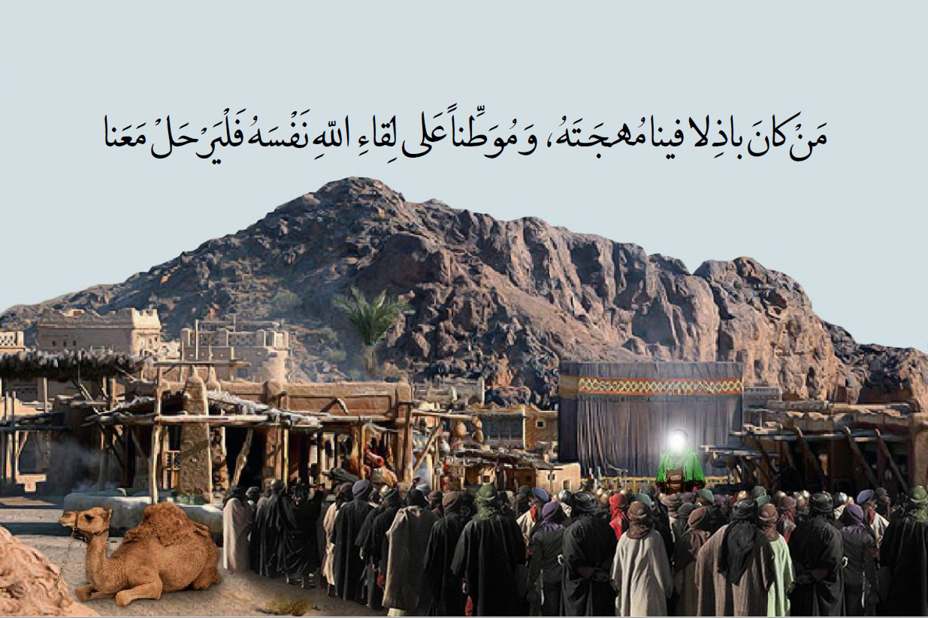

Zobalah

Muhammad ibn Ash’ath’s envoy comes to Imam (as)
According to the last will of Moslim ibn Aqeel, Muhammad ibn Ash’ath sent an envoy who carried a letter to Imam (as) to inform his holiness about the martyrdom of Moslim and Hani. When Imam (as) reached Zobalah, the envoy of Muhammad ibn Ash’ath went to Imam (as) with a letter which contained the news of fate of Moslim and disloyalty and betray of the Kufans after making pledge of allegiance with him.

Receiving the news of the martyrdom of Abdullah ibn Buqhtor
Before receiving the news of Moslim’s martyrdom, Imam Hussain (as) sent his foster-brother, Abdullah ibn Buqhtor, to Kufa with a letter. But he was arrested by the soldiers of Hussayn ibn Numayr and was taken to Ubaydullah Ibn Ziyad. Ubaydullah told him to go on top of the palace and curse Imam Hussain (as). Abdullah ibn Buqhtor went up and in front of the crowd shouted, “O the people, I am the messenger of Hussain (as). O people, assist him against Ibn Ziyad, the son of Marjanah who was the daughter of Sumayyad the unchaste.” Ubaydullah ordered to throw him down from above the palace and martyred him.When Imam (as) heared the news of the martyrdom Abdullah ibn Buqhtor took out a letter and said, “Our Shias left us alone. Whoever wants to return is at ease and there’s none of our rights upon him.” At this moment, the people scattered from Imam’s right and left and only a few stayed with him.

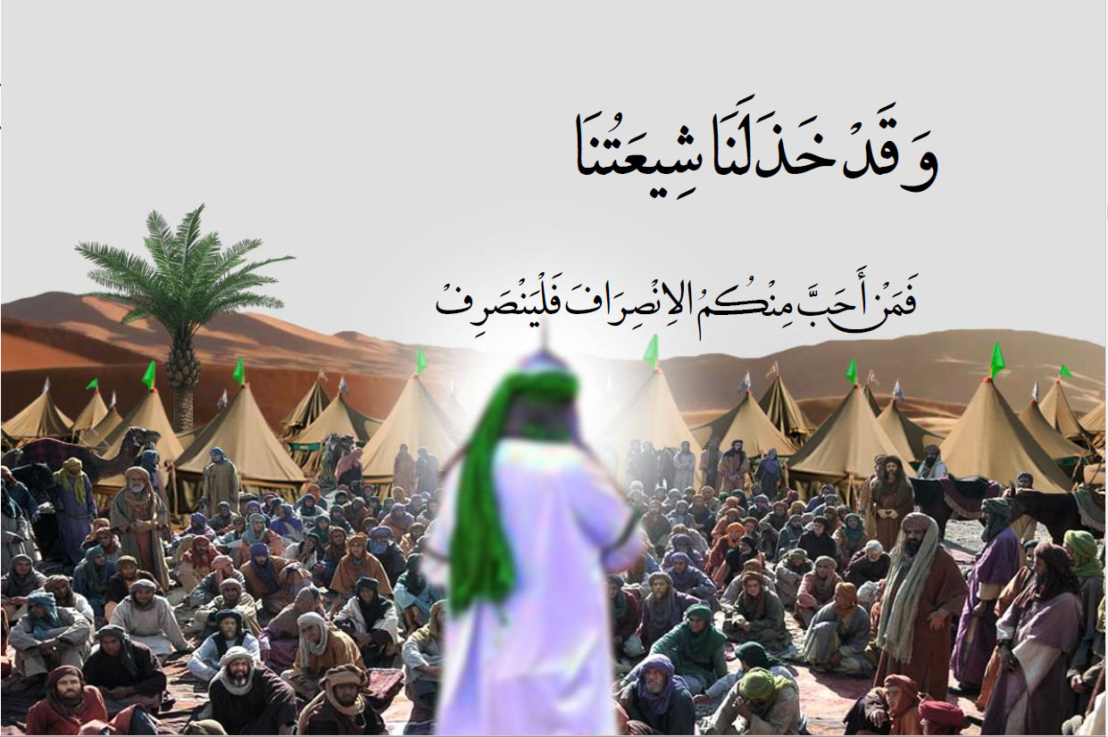

Baidhah
Imam’s caravan with Hurr’s army moved until they reached Baidhah. There Imam (as) got another chance to deliver a speech and explain to his companions and Hurr’s army the reason for his uprising. In his sermon, Imam (as) said:
O people! the Holy Prophet (S) said, “Whoever sees a tyrant ruler making lawful what Allah has forbidden, breaking the covenant of Allah, opposing the sunnah of the Messenger of Allah and behaving sinfully and unjustly with the servants of Allah, but does not [rise to] oppose such a ruler neither by his action nor his word, then it is binding on Allah to make him enter where the tyrant shall enter. Indeed these people (Bani Umayyad) have clung to the obedience of Satan and have forsaken obeying the All-Merciful. They openly indulge in corruption and have stopped the enforcement of hudud (Allah’s decrees). They have made lawful what Allah has forbidden and have prohibited that which Allah has made lawful. And I am more entitled to bring changes than anyone else.
Your letters expressed your allegiance with me. If you’re still on your pledge, you have reached your human values and have shown sound judgement; for I am son of Ali (as) and the Prophet’s daughter. But if you break your pledge, you have verily taken the wrong path. Thus whoever breaks his pledge, it is to his own detriment.”
Imam (as) departed from Baidhah after delivering this sermon. Hurr also accompanied his holiness.

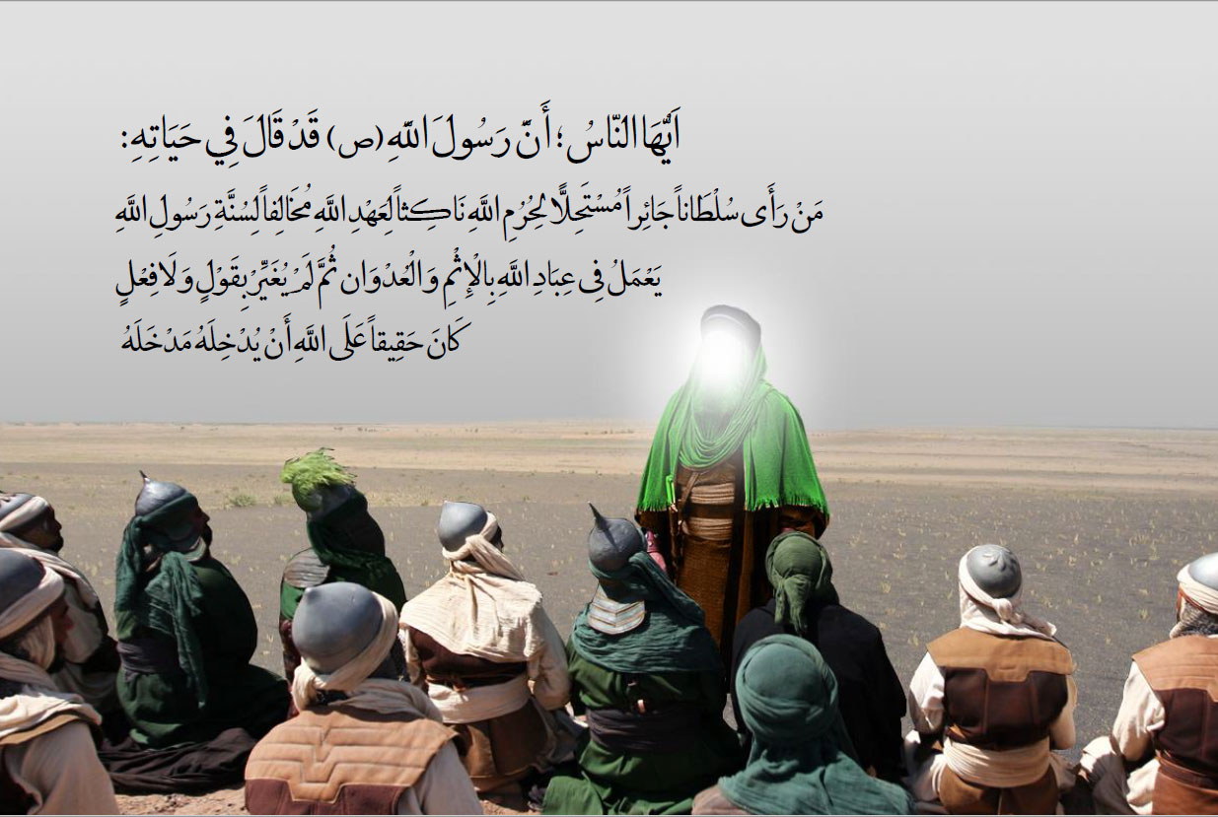

Nainawa

Nainawa
In the land of Nainawa, a horse rider came to Hurr from Ibn Ziyad carrying a letter with this notion: “When this letter reaches you, be hard on Hussain (as) and make him come to a halt. But only let him stop in an open place, with no shelter and water.”
Hurr read the letter and told Imam (as) and his companions that it was a letter from Amir Ubaydullah ibn Ziyad in which he had ordered Hurr to be hard on them.
At this moment Zuhair ibn Qain suggested Imam (as) to fight with Hurr’s army but his eminence said: “I will not be the first to start the war”. Then Imam (as) said to Hurr: let’s go further and disembark there. Hurr and his men alongside with Imam (as) continued the path until they arrived in Karbala. Imam Hussain (as) inquired: “What is the name of this land?”
They replied Karbala. Then Imam (as) said, “This is the place surrounded with affliction and calamity. When proceeding toward Seffin, my father passed this land and I was with him. He halted and inquired about the name of this land. He was told the name. Then he said: This is the place where they will come and this is where their blood will be shed. They asked whom [are you talking about]? He said a caravan from the Muhammad’s household will come here.
Then Imam Hussain (as) said: “Disembark here! By Allah here is our halting place and the place wherein our blood will be shed. By Allah, this place is where our graves will be. By Allah, this is the place where our families will be captivated. My grandfather informed me about this”.

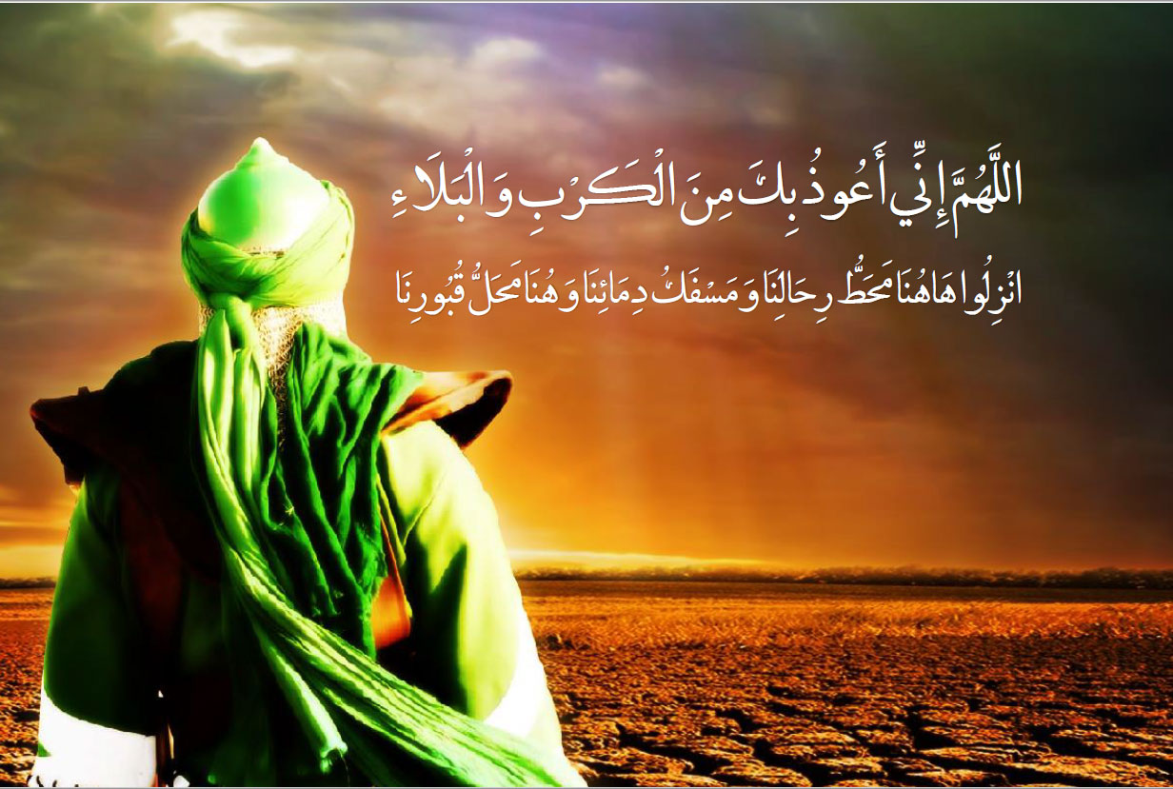

Amir al-Mumineen’s Prophecy Came True
When Harthama ibn Salim entered the land of Karbala with Ibn Ziyad’s army, remembered the words of Imam Ali (as) at Seffin Battle. In Seffin Harthama was in the army of Imam Ali (as). On the way to Seffin, when they reached Karbala, Amir al-Mumineen (as) grabed a handful of soil and smelled it and then said, “O the soil, on the day of judgement, a group of people will be resurrected from you who will enter the paradise without reckoning.”
Harthama went to Imam Hussain (as) and related Imam Ali (as)’s words for his eminence.
Imam (as) asked Harthama as to whether he was with or against Imam (as)? He replied: “O the son of the Holy Prophet (S), I am neither with you nor against you; I have left my family and children and have come here. I am fearful of the son of Ziyad about them.
Imam Hussain (as) said, “Then leave here as soon as possible so that you won’t witness our murdur. I swear by the God in whose hand my life is, whoever witnesses our murder and doesn’t assist us, Allah will throw him in the hell.”
Upon hearing this matter, Harthama escaped that land quickly so that he won’t witness Imam’s martyrdom.

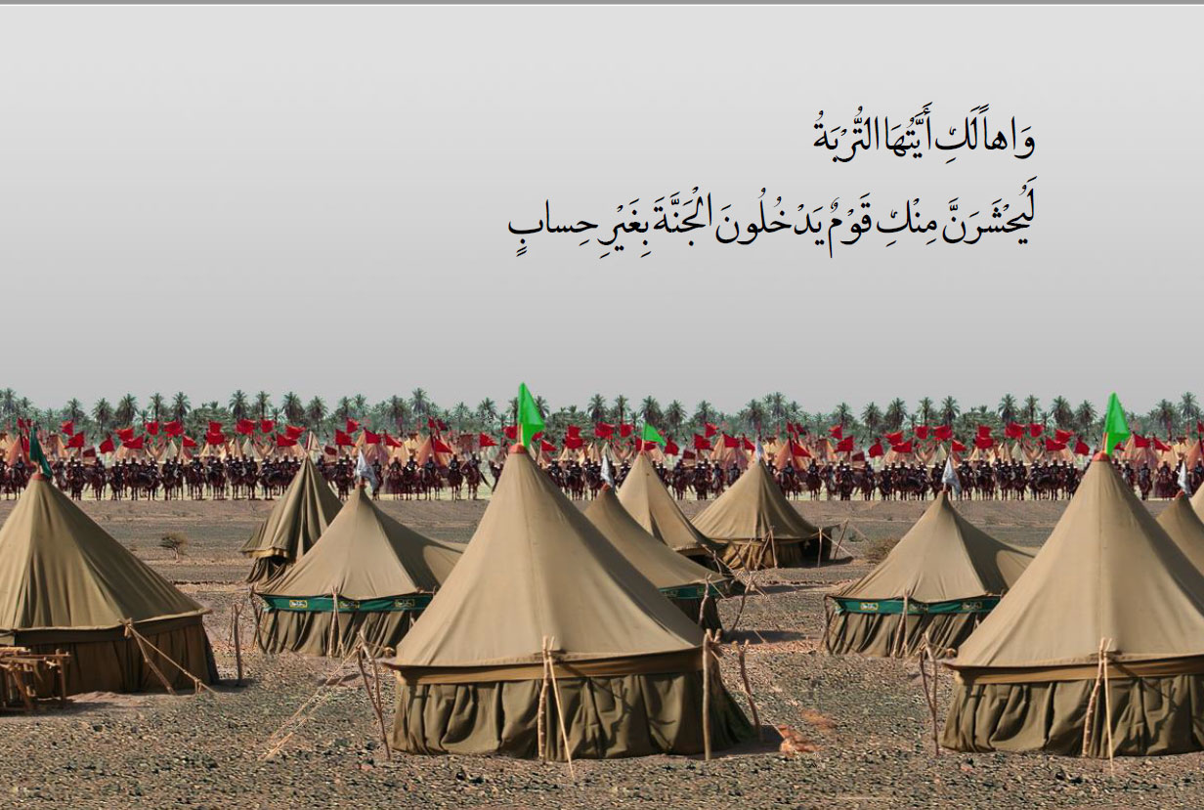

Setting up the Tents
After the caravan of Imam Hussain (as) dismounted in Karbala, they first pitched the tents of Imam (as) and his family and then the relatives and companions of his eminence pitched their tents around theirs.
When pitching the tents, Imam Hussain (as) made the reedy and shrubbery behind the tents so that they only face enemy from one side.
After Imam and his companions encamped, Hurr too camped in front of his holiness. Then he informed Ibn Ziyad that Imam has entered Karbala. Hence Ibn Ziyad wrote a letter to Imam Hussain (as) with this concept: Now then O Hussain! I have been informed that you have halted at Karbala. Yazeed has written to either kill you, or you submit yourself to me and Yazeed ibn Mu’awiyah. Greetings.”
When Imam (as) received this letter and read it, he said, “I have no answer for this letter; because he deserves God’s chastisement.”

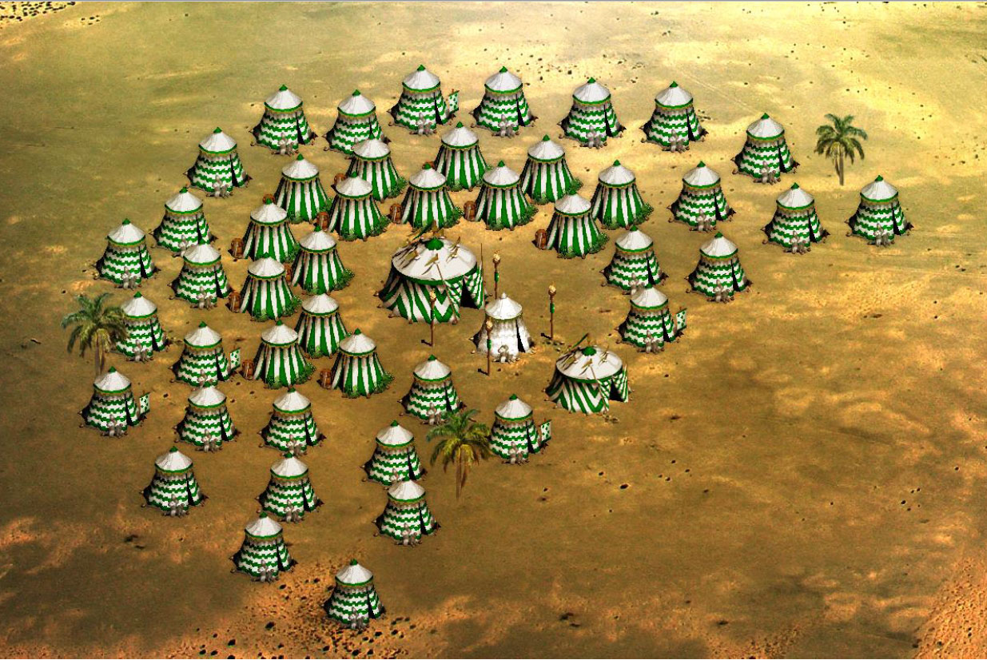

Arrival of Umar ibn Sa’d in Karbala
Prior to Imam Hussain (as)’s coming to Iraq, Umar ibn Sa’d had been granted the governorship of Rey (a city near Tehran, Iran) and was missioned by Ibn Ziyad to fight the Deylaman. Umar Ibn Sa’d had encamped in Hamam A’yan with an army of four thousand troops when he received an order to return to Kufa because of Imam’s entrance to Iraq. Ubaydullah ibn Ziyad gave him the mission of going to Imam Hussain (as). Umar ibn Sa’d asked Ubaydullah to exempt him from this mission. Ubaydullah replied: “It is agreed, but in case you give us back the decree of governing Rey.” When Ubaydullah said this, Umar ibn Sa’d accepted to go to Karbala to fight with Imam Hussain (as). Hamzah ibn Mughayrah, Umar ibn Sa’d’s nephew, said to him: “I request you in the name of Allah not to confront Hussain, for by doing this you will be sinning and severing the bonds of relationship with him. By Allah! Even if you have the wealth and the kingdom of all the earth and abandon it, it is better for you than going to the presence of the Almighty Allah with the blood of Hussain upon your hand.” Umar ibn Sa’d arrived in Karbala on Muharram 3 and joined Hurr’s Army. After camping in Karbala, he missioned every tribe’s head who had written letters to Imam Hussain (as) to go to Imam (as) and ask him about his aim of coming to Kufa. However, they all were ashamed to obey this order and rejected the idea. Then Qurra ibn Qais accepted the responsibility of asking this question from Imam (as) and went to him. Imam (as) replied: The people of your town have written to me and requested me to come here. Then if they don’t want my presence I shall return back. Then Qurra ibn Qais went to Umar Sa’d to tell him about Imam’s answer.

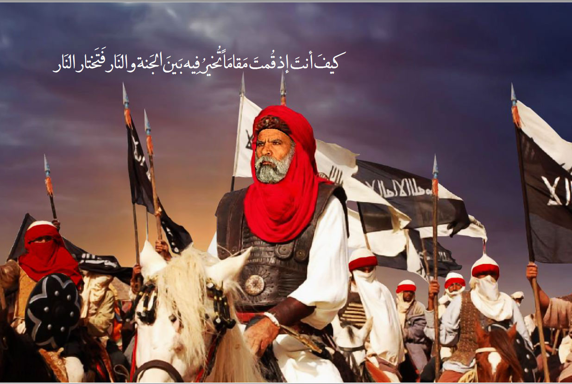

Kufan’s Dispatch to Fight Imam Hussain (as)
After sending Umar ibn Sa’d to Karbala, Ubaydullah ibn Ziyad mounted the pulpit and praised Mu’awiyah and falsely and insincerely described his virtues and generosity. Then he said, “Yazeed has followed his father’s footsteps in behavior and manner. Therefore all the tribes’ heads and Kufa’s residents must leave the city to join the army and anyone who transgresses the order, he won’t be secure anymore.”
Then Ibn Ziyad missioned some men to go among the people and encourage them to join the army and to threaten them about the cosequences of their decision.
There’s a disagreement between the historians regarding the number of Umar ibn Sa’d’s army who were dispatched to fight against Imam Hussain (as) and also in regard with the names of the commanders of Kufa’s army.
According to Ibn Shahr Ashub, Hurr with a thousand people, Ka’b ibn Talha with three thousand men, Umar ibn Sa’d with four thousand wariors, Shimr ibn Dhil Jawshan with four thousand troops, Yazeed ibn Rekab Kalbi with two thousand people, Husayn ibn Numayr with four thousand men, Madhayer ibn Rahinah Mazeni with three thousand combatants, Nasr ibn Harshe with two thousand wariors, Shabath ibn Reb’I with a thousand persons, and Hajjar ibn Abjar with a thousand men entered Karbala until Muharram 6th.

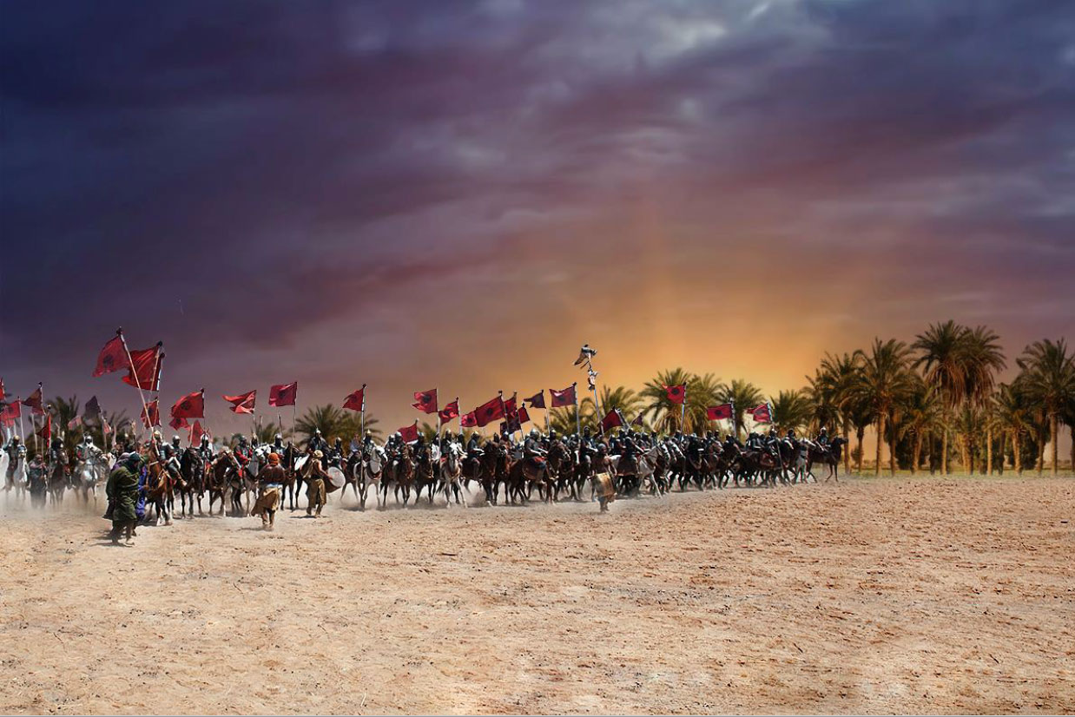

The Order of Forbidding the Water for Imam Hussain (as)’s Caravan
Umar bin Sa‘d received a letter from ‘Ubaydullah bin Ziyad which read:
“Prevent Hussain (as) and his companions from reaching water. They should not taste [even] a drop of it as was done to the commander of the faithful, Uthman bin Affan, the pious, the chaste and the oppressed!”
Forbidding water in Karbala with this pretext that when besieging Uthman’s House and killing him, he was denied of access to water, is one of the greatest false advertising; because contrary to what was said in Karbala, Imam Ali (as) and his children not only weren’t present in the event, but also despite the objection of the revolutionaries, Imam Ali (as) sent him three waterskins full of water and told Hassanain (as) to go to Uthman’s house in order to help him and in that event Imam Hassan (as) was injured.

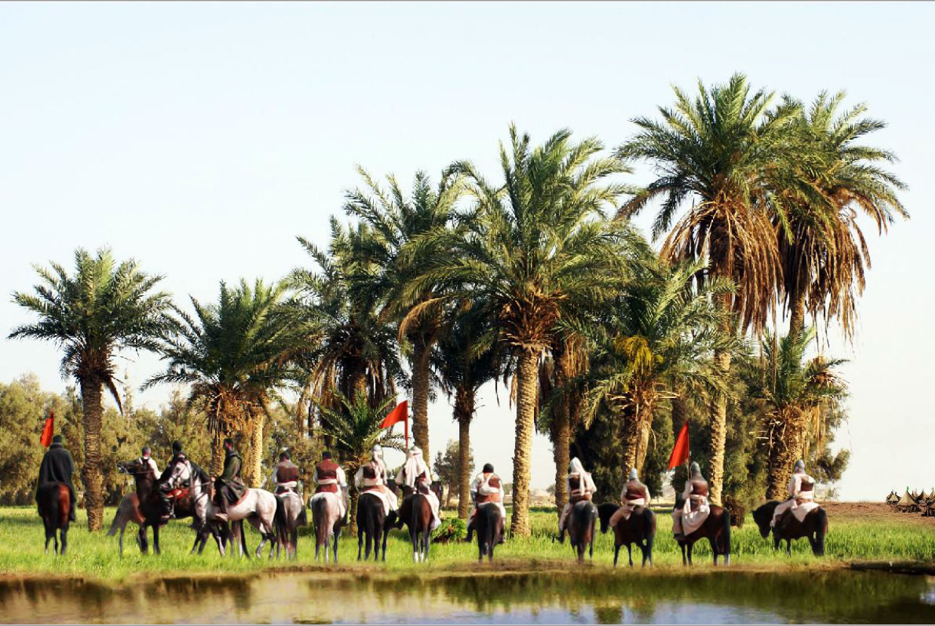

Umar ibn Sa’d Meets with Imam Hussain (as)
From the early days of Muharram, Imam Hussain (as) had some meetings with Umar ibn Sa’d and tried to dissuade him from the fight several times. Imam Hussain (as) sent Amr ibn Qurdhah ibn Ka’b al-Ansari to Ibn Sa’d [saying]: “Meet me at night somewhere between the two armies.” So [at night] Umar ibn Sa’d came out with around twenty horsemen and so did Imam Hussain (as). When they met each other, Imam Hussain (as) ordered his companions to move away from him and so did Umar bin Sa’d.
Then Imam Hussain (as) said to Umar ibn Sa’d: “Woe be to you! Do you not fear the Lord to whom is your return and you want to fight me while you know whose son I am and what relation do I bear with the Holy Prophet (S)? Leave this party and accompany me so that you become close to Allah.”
Umar ibn Sa’d said that he was afraid that they may destroy his house. Imam (as) said: I will provide you a house. He said: they will confiscate my properties. Imam Said: I will give you better than that. Umar ibn Sa’d became silent and didn’t say anything.
While leaving there, Imam (as) said: May Allah kill you on your bed soon and may He never fogive you on the day of resurrection; I wish that you won’t eat the Iraq’s wheat but little. Umar ibn Sa’d said: if there won’t be the wheat, barly will suffice me. Then he returned to his army.

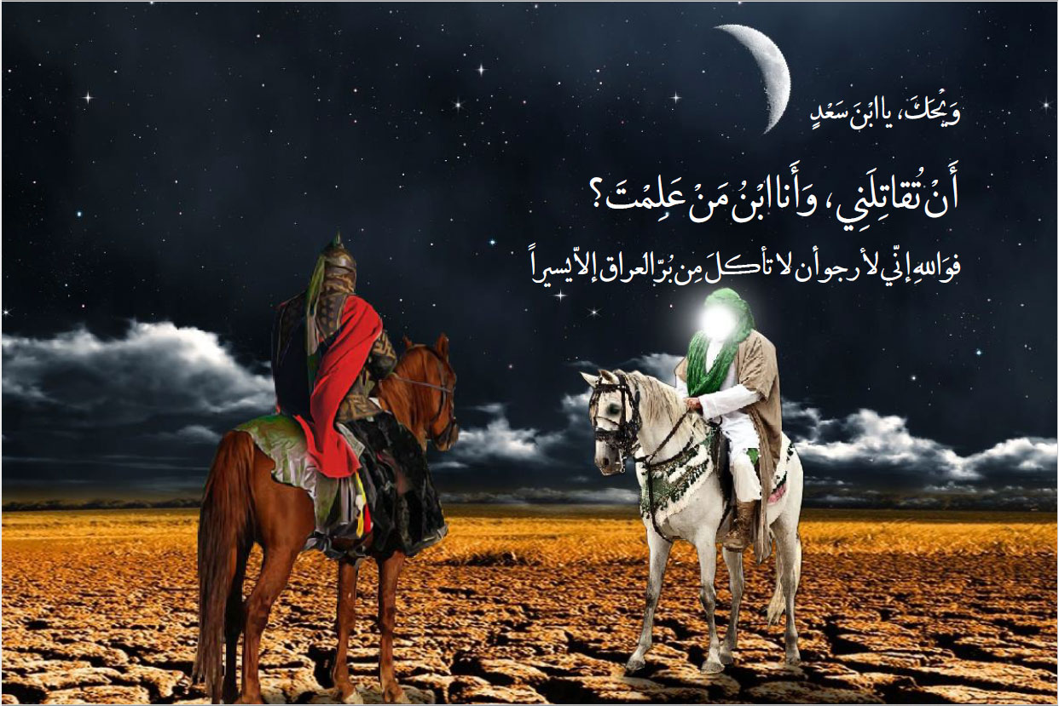

Abbas ibn Ali (as) Brings Water
When the thirst bothered Imam (as) and his companions, his eminence sent his brother, Abbas (AS), along with thirty horse-riders and twenty others on foot with twenty waterskins to the Euphrates River. They went near the Euphrates, while Nafi’ ibn Hilal was in front of them holding the flag.
Amr ibn Hajjaj (the one in charge of the river) called out loud: who are you and what have you come here for? Nafi’ said: we have come here to drink the water from which you have prevented us.
Amr ibn Hajjaj said: imbibe then and cool your eyes! Nafi’ answered: “No, by Allah, I will never drink one drop of this water while Hussain and the Ahl al-Bayt with him and their supporters are thirsty.”
At this time, those accompanying Nafi’ came forward. Amr said: this is not possible and there’s no way to give water to these. We are here to prevent them from water. Nafi’ then called upon his companions to fill their waterskins and they did so. It was then that those under the command of Ibn Hajjaj attacked them. Some of them kept watering their bags anyway while others were defending them headed by the one who grew up in the very lap of Hayderi bravery, namely Abul-Fadhl al-Abbas ibn Ali (as). Finally, Imam Hussain (as)’s companions returned back to Imam Hussain (as) with full bags. Thereafter, Abbas (as) was entitled as “Saqqa”.

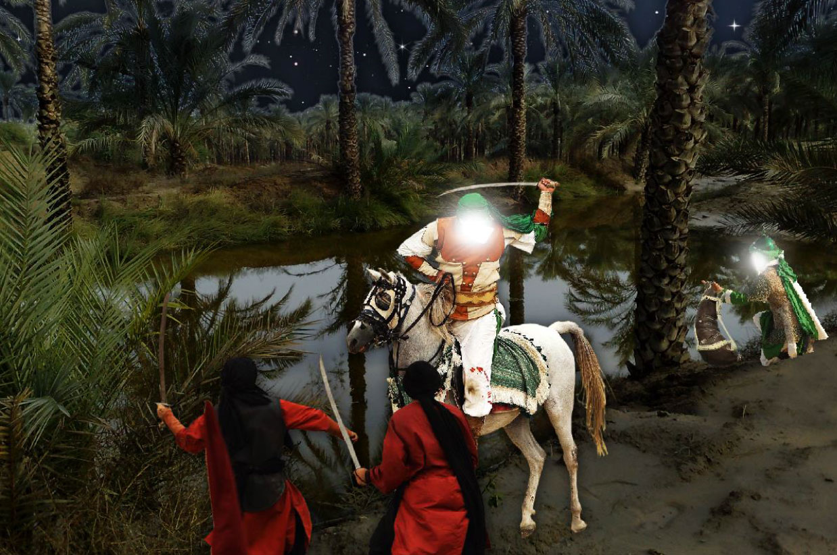

Shimr ibn Dhil Jawshan Comes to Karbala with Ibn Ziyad’s Letter
After his meeting with Imam Hussain (as), Umar Sa’d wrote a letter to Ibn Ziyad in which he expressed his delightsaying that the matter is finished with peace and Hussain (as) has stepped back from his position. Ibn Sa’d wanted to pass this crises with a peaceful solution and attain the government of Rey. Having read Ibn Sa’d's letter, Shimr ibn Dhil Jawshan said to him: Do you really accept such an offer from him after having settled in your land? By Allah! If he ever departs from your land without making an agreement with you, he will get even stronger, while you will get weaker. Do not give him this privilege because it will degrade you. Ubaydullah wrote a letter and ordered Shimr to deliver it to Umar ibn Sa’d. Ubaydullah’s letter to Umar Sa’d read: “I did not dispatch you to Hussain (as) so that you would spare him, nor to negotiate with him, nor to give him any glimpse of hope of security, nor did I dispatch you so that you would intercede on his behalf with me. See if Hussain (as) and his companions surrender to my authority; if so, send them to me safely; if not, launch attack on them and kill them and mutilate their bodies, for they surely deserve it. If Hussain is killed, let the horses trample over his chest and back. I do not think that this will hurt him after his death, but this is in fulfillment of a promise that I had made to do that. If you carry out our order, we shall reward you as someone who listens to us and who obeys, but if you refuse, then remove yourself from our business and our troops, and let Shimr Ibn Dhul Jawshan take charge of the army, for we have granted him authority to do so. In the evening of Muharram 9, Shimr ibn Dhil Jawshan reached Karbala with the new command of Ubaydullah and gave the letter to Umar Sa’d.

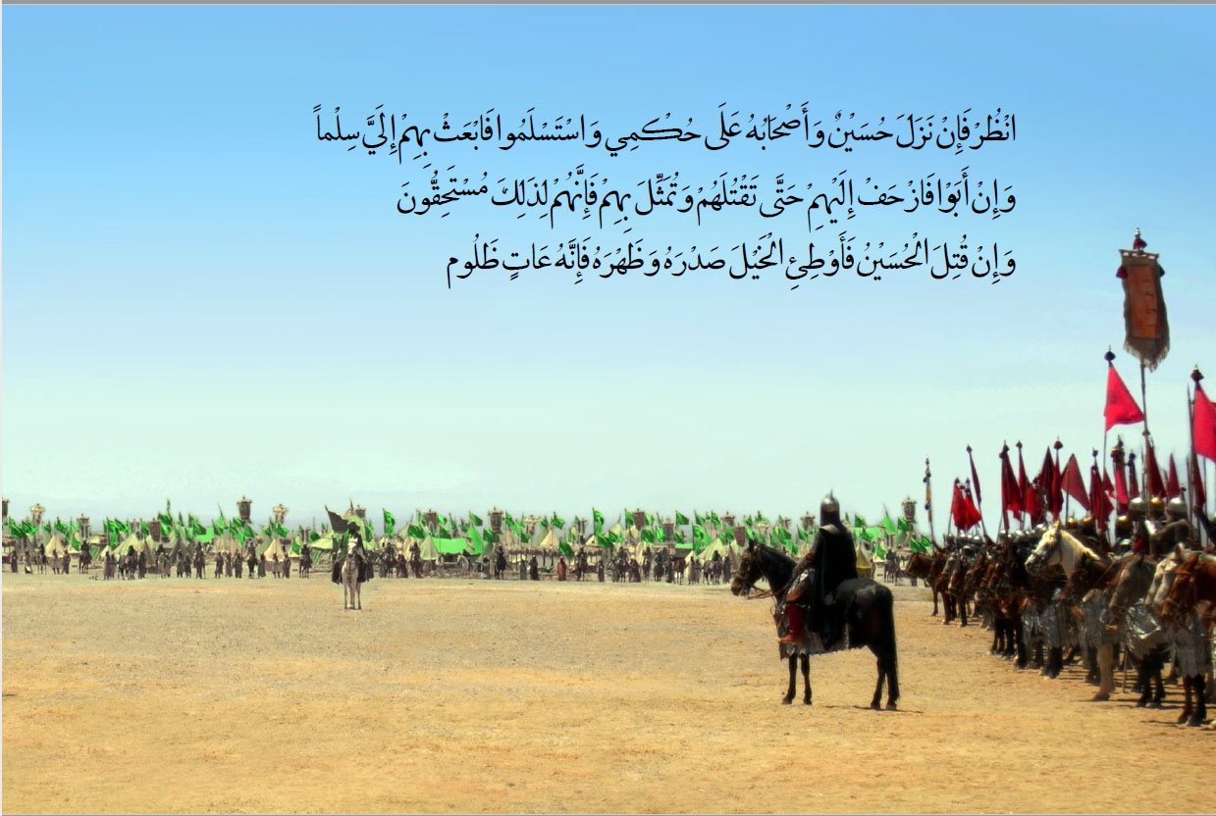

Imam Hussain (as) Asking for a Respite
When the army of Umar ibn Sa’d got ready for the battle, Abbas (as) came to Imam (as) and said: O dear brother the enemy’s army is approaching you. Imam Hussain (as) stood up and said: “O Abbas! Get on your mount, may I be sacrificed for you O brother, and go to meet them and ask them what the matter with them is, what has appeared [appropriate] to them and what has brought them forward?” They replied: “We have received an order from the governor that we should offer you [an opportunity] to submit to his authority, or else we should fight you.” Abbas (as) said: “Do not hurry until I go back to Aba Abdillah and tell him what you have said.” Abbas ibn Ali (AS) went to Imam Hussain (as) with the proposal of Umar ibn Sa’d. Imam Hussain (as) said: “Go back to them and if you can, delay them until the morning and keep them away from us this evening. Perhaps we may [be able to] spend the night offering prayers for our Lord, supplicating to him and seeking his forgiveness; for he knows that I have always loved praying to Him, reciting His Book, [making] many invocations and seeking His forgiveness.” So Abbas ibn Ali (as) galloped his horse and went back to them and said: “O people! Abu Abdillah is requesting you to grant him respite for tonight, so that he may consider the matter; for there has not taken place any discussion so far between you and him concerning this proposal. So we shall meet in the morning, if Allah wills. Either we would give consent to it and do what you want from us and are insisting upon; or we would dislike it and therefore reject it.” Amr bin Hajjaj said: “Glory be to Allah! By Allah! Even if they were from Turk and Dailam and had asked such a thing, we would have fulfilled this demand.”

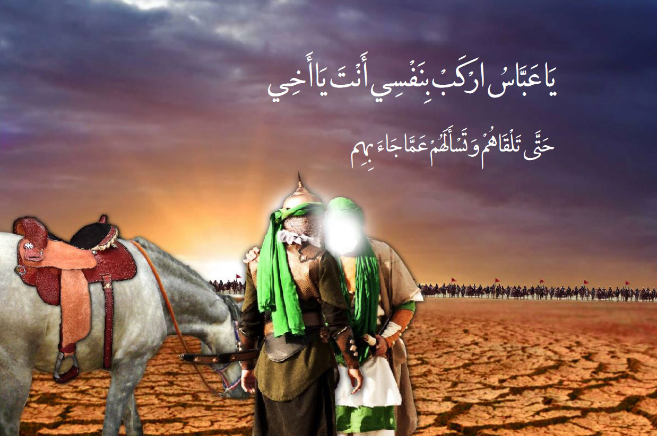

Imam’s Speech with His Companions on the Night of Ashura
At the early hours of the night preceeding Ashura, Imam Hussain (as) gathered his companions and said to them: “I praise Allah, the Blessed, the Exalted, with the best of praises. I praise him in ease and difficulty. O Allah, I praise You for honouring us with the prophethood, teaching us the Qur’an and making us comprehend your religion. You granted us with [the faculties of] hearing, sight and the hearts; and you did not make us among the idolaters. And then now, I know of no companions more loyal and better than my companions, nor of any household more righteous and kinder than my family. May Allah reward you all the best of rewards on my behalf. Beware that I know what will happen between us and these enemies. Now, you have my leave to go; thus you are all free to leave and there’s no allegiance from me upon you!” Abbas ibn Ali (as) was the first to speak. He said to Imam: “Why should we do [that]? Just in order to remain alive after you?! May Allah never show us that [day]!” Then Muslim ibn Awsajah stood up and said: “If we leave you alone, what excuse would we give to Allah for not fulfilling your rights [on us]? By Allah! … I will not leave you until I die with you!” After that Saeed ibn Abdullah Hanafi said: “No O the son of the Messenger of Allah (S)! By Allah we will not leave you until Allah knows that we have protected you in the absence of His Prophet (S). By Allah! If I knew that I would be killed in your way and then be revived and then be burnt alive and then my ashes would be scattered, and that would be done to me seventy times, I would [still] not leave you until I was martyred under your command and at your company.”

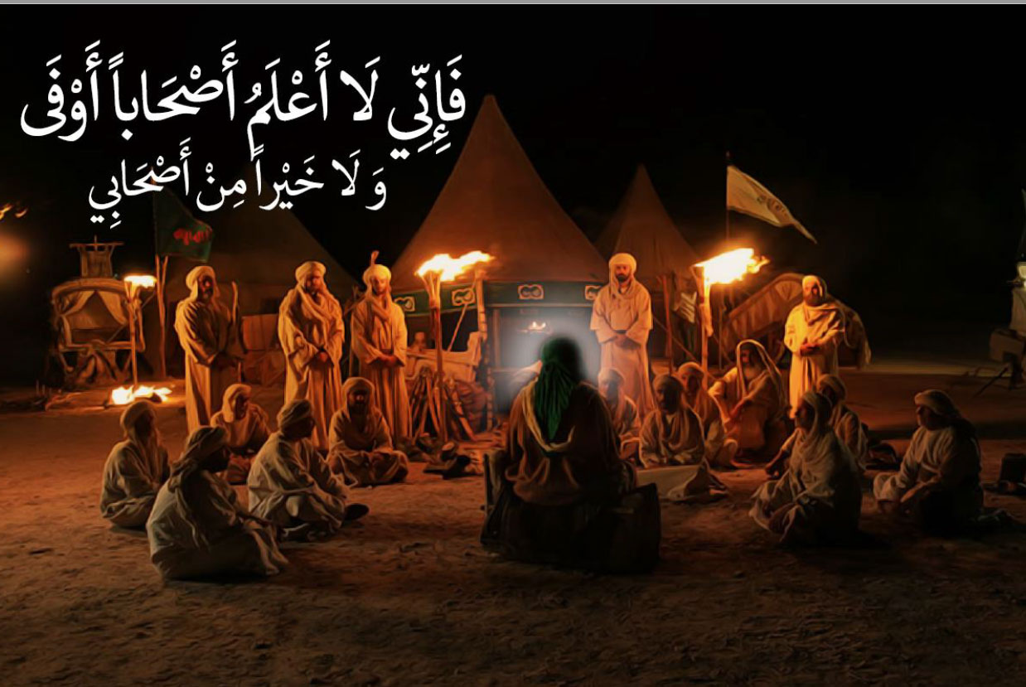

The Day of Ashura

The Supplication of Imam Hussain (as) in the Morning of Ashura
In the morning of Ashura, after the enemy’s army confronted Imam Hussain (as), his eminence raised his hands in prayer and said: “O Lord! I depend on you in every tribulation and affliction and am hopeful of Your blessing in every hardship. In every difficulty which I confront, You are my only remedy and resort. There have been many great distresses which weakened my heart and no remedy for it was available. The friends did not assist me and the enemies rejoiced at my misfortune.
However, when I ceased to seek assistance from everyone except You and sought the remedy only from You, You provided me solace and relief and removed the difficulty. Every blessing and goodness only reaches us from You and everything should only be sought from You”.

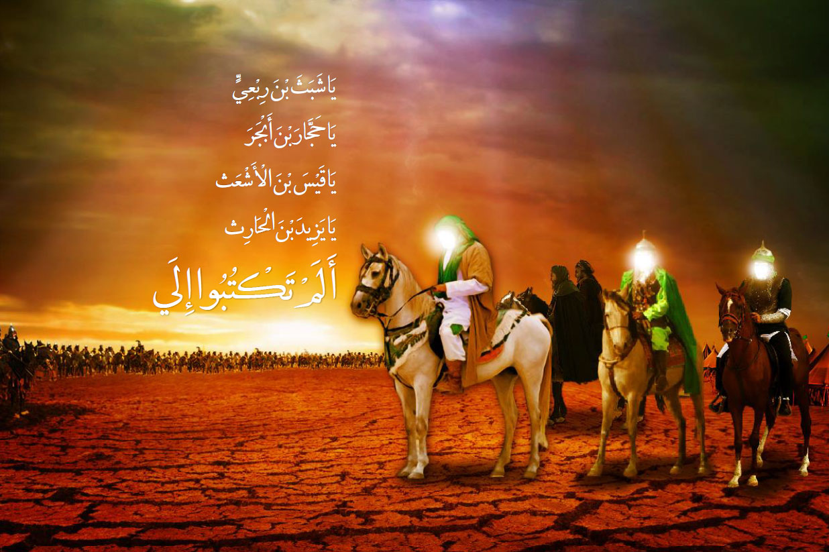

Hurr ibn Yazeed Riyahi Joins the Army of Imam Hussain (as)
Addressing the army of Umar ibn Sa’d, the Imam (as) said: “You don’t listen to my words because your stomachs are filled with Haram (unlawful gains) and Allah the Almighty has sealed your hearts. O people! May you be ruined and afflicted. You enthusiastically invited us to assist you, and we hastened to do so. Then now you have unsheathed those very swords, which you had taken to defend us with, and you have kindled the fire for us which we ourselves had kindled for your enemies and ours. God’s curse be upon those who break their covenant after having made it. You declared God the Amighty as the witness and guarantor of your pact [but you breached your promise]. So by Allah, you are the very betrayors that verily treachery and breach of trust has been your old custom….
Now this illegitimate son of the illegitimate father (Ubaydullah ibn Ziyad) has stationed me between unsheathing the swords and bearing humiliation, and far be it that we accept humiliation.” Having said so, he continued his speech thus: “By Allah! You shall not linger after this incident except as long as one stays on his horseback. The grinding stones shall then spin you, shaking you as the axis shakes; this is a promise which my father have promised me the way he had been promised by my grandfather, the Messenger of Allah (sawa).” Then Imam (as) called out: “Is there any one who would hasten to assist us in the name of Allah? Is there any one who would defend the Household of the Prophet?”
After having heard this call, Hurr ibn Yazeed Riyahi joined the army of Imam Hussain (as).

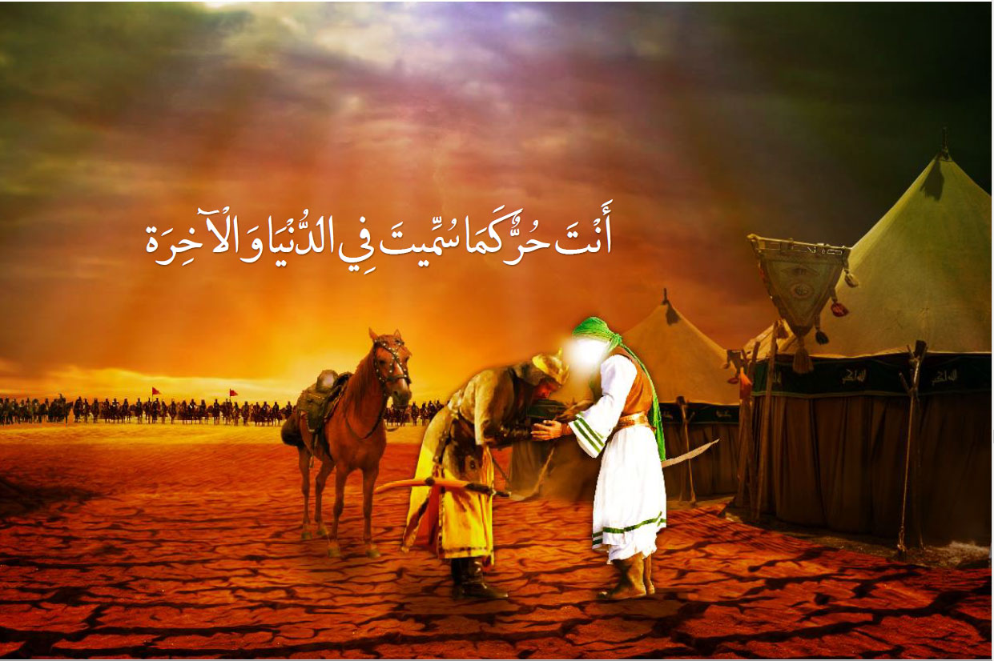

The Commencement of the Battle
Umar ibn Sa‘d advanced towards Imam Hussain (as) and his companions and called his retainer “Duraid” to take the standard closer and he did so. Then Umar ibn Sa’d put an arrow in his bow and shot it toward Imam Hussain (as) and said: “Testify for me with the governor Ubaydullah ibn Ziyad that I was the first one who shot an arrow [to Hussain]. After that his troops began to shoot the arrows and thus the war started. Imam Hussain (as) said to his companions, “These arrows are messengers of these people to you, then, Stand, may Allah be Merciful to you, and get prepared for the death from which there’s no escape.

The First Group Attack
Amr ibn Hajjaj, who had the command of the right wing of the enemy’s army, launched an attack [with his troops] on Imam’s army. When he [and his forces] drew near to Imam Hussain (as), the followers of the Imam (as) knelt down and pointed their spears at them. Hence, the horses [of the attackers] became afraid of the spears and could not advance against the spears and began to retreat.While retreating, the companions of Imam Hussain (as) began to shoot arrows at them, killing some of them and wounding some others.

The Second Attack of Umar ibn Sa’d’s Army
Then Amr ibn Hajjaj, the commander of the right wing of Ibn Sa’d’s army, shouted at the Kufans and said: O foolish men! Do you know whom you are fighting? These are the valorous knights of Kufa, who are ready to sacrifice their lives. Thus no one should go forward to fight them in single combat. At this time, Amr ibn Hajjaj launched an attack on the companions of Imam Hussain (as) from the side of the Euphrates and the two armies fought each other for some time. Moslim ibn Awsajah attained martyrdom in this attack. Moslim ibn Awsajah Asadi was the first companion of Imam Hussain (as) who acquired the tawfiq to be martyred.

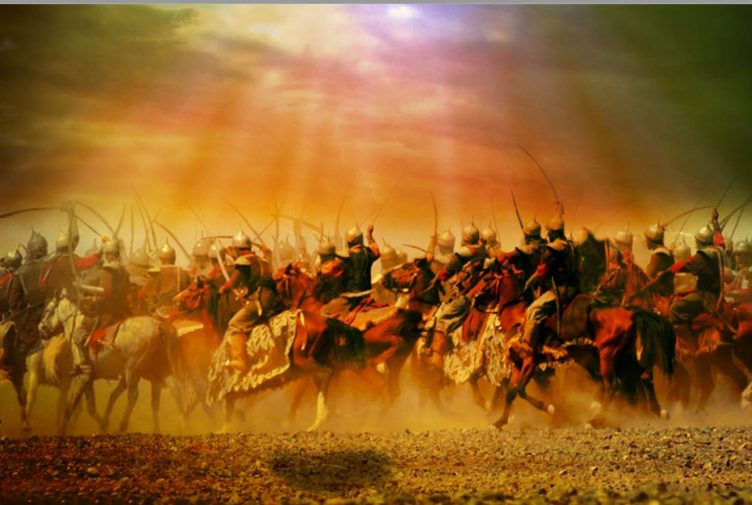

The Third Attack
Shimr ibn Dhil Jawshan who was the commander of the left wing of Ibn Sa’d’s army launched an attack with his forces on the companions of Imam Hussain (as). They stood firm against them and attacked them with their spears forcing the attackers to withdraw.
Then Imam (as) and his companions were attacked from all sides and Abdullah ibn Umayr Kalbi, who had previously fought the enemy in a single combat and killed some of them, was martyred.
When Abdullah ibn Umayr was martyred his wife, Umm Wahab, walked out of her tent and went towards his corpse and sat at his head. Wiping the dust and the blood from it, she said, “Congratulations for having earned Paradise! I plead to Allah Who blessed you with Paradise to make me join you.” At that moment Shimr told his slave “Rustam” to hit her head with a rod and he did so. Her head was broken and she died there and then.

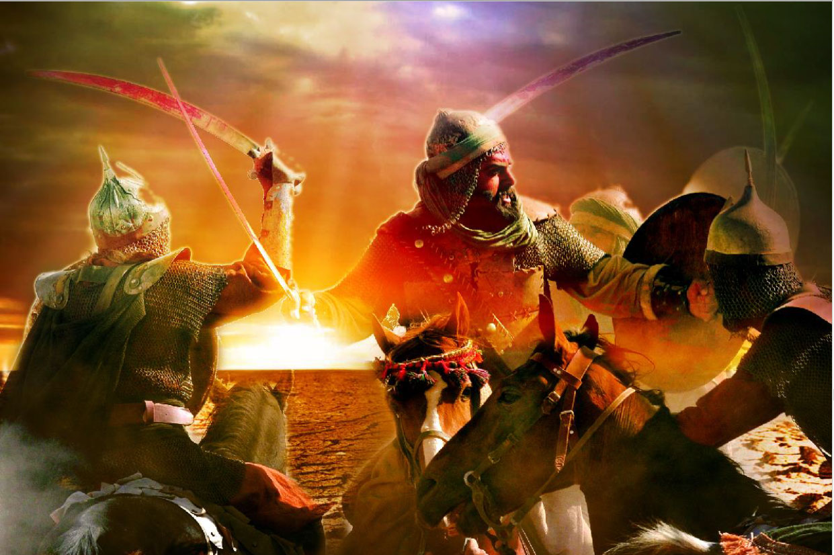

The Noon Prayer of Ashura
In the turmoil of the war, Abu Thumamah reminded Imam (as) about the noon prayer. It was the time for noon prayers.
Imam Hussain (as) ordered Zuhair ibn Qain and Saeed ibn Abdullah Hanafi to stand in front of Imam (as) and the performers of the prayers with half of the forces [to be careful about the enemy] and Imam Hussain (as) performed the Prayers of fear (Salat al-Khawf) with the other half. The enemy shot an arrow towards Imam Hussain (as). Saeed ibn Abdullah came forward and subjected himself to that arrow. He continued to be shot at, as he remained standing in front of Imam Hussain (as). At the end of the prayers Saeed's wounds became overwhelming and he fell on the ground as he was supplicating thus: “O Allah! Curse them as You cursed the peoples of ‘Ad and Thamud. O my Lord convey my Salam to Your Prophet (S) and tell him about the pain of the wounds which I have received, for I desired Your rewards when I supported the offspring of Your Prophet, Allah’s peace and blessings be upon him and his progeny.” Then he passed away.

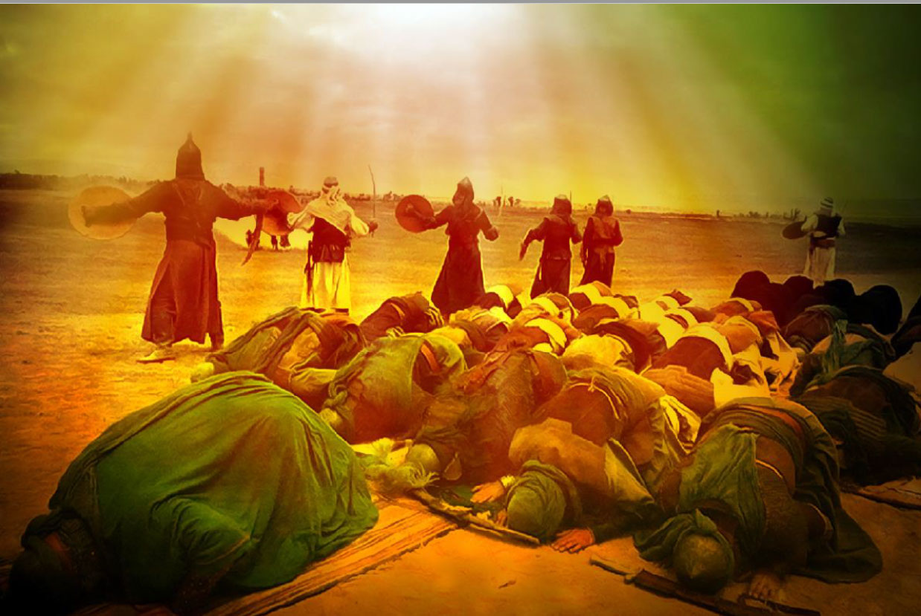

Martyrdom of Jawn, the Retainer of Abu Dharr Ghifari
After Amr ibn Qaradhah, Jawn, the freed retainer of Abu Dharr al-Ghifari, who was a black slave went to the battle field. Imam Hussain (as) told him, “I give you permission to leave, for you were among us in our times of happiness, then do not afflict yourself in our calamities.”
Jawn replied, “O son of the Messenger of Allah (sawa)! Is it meritorious for me who have been fed at your place during the days of happiness [and security], to desert you in hardships? By Allah! The smell of my sweat is smelly, my lineage is low, and my color is dark. Then permit me Paradise, so that my smell may turn into a pleasant fragrance, my lineage into a noble one and my face may be illuminated. By Allah! No, I will never desert you until this black blood of mine mixes with your pure blood.”
Then he fought until attained martyrdom.

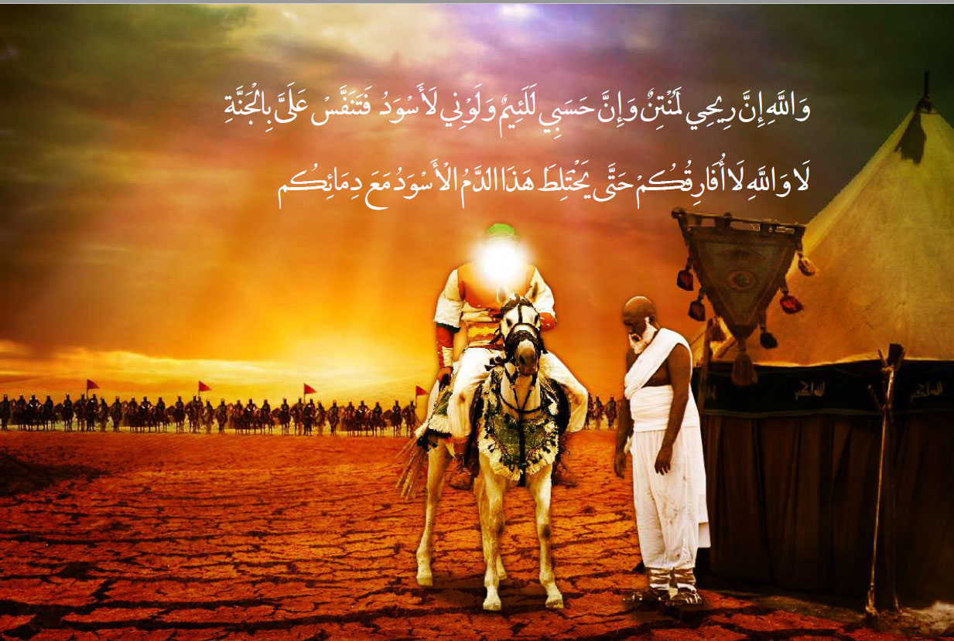

Fight and Martyrdom of Ali Akbar (as)
After the martyrdom of the staunch companions of Imam (as), the first one from Bani Hashim who became martyred was Ali Akbar (as). When Hazrat Ali Akbar (as) asked permission from his father for battle. Imam (as) gave him permission and then looked at him with dejection, and lowered his eyes while tears flowed from them. Imam (as) said, “O Allah! Be a witness upon these men that the youth who resembles your Prophet the most in character, appearance and speech is proceeding towards them. Whenever we desired beholding the face of your Prophet, we would look at him.” Then Ali Akbar attacked the enemey while reciting the following Rajaz verses: I am Ali, son of Hussain Ibn Ali; By the Lord of the House, we possess superiority while bearing relation with the Prophet (S)”. Ali Akbar kept charging at their right and left wings, fighting them until he killed many of them. Then he returned back to his venerable father and said, “O dear father! Verily the thirst killed me and the heavy iron (armor) made me impatient”. Imam (as) said: “Fight for a while! Very soon you will meet your grandfather, the Messenger of Allah (S) who will give you a drink after which you shall never suffer of thirst.” Ali Akbar (AS) went back to the battlefield and advanced towards the enemies a second time with courage eminiscent of [his grandfather,] Imam Ali (as). He killed a large number of the enemies till Murra ibn Munqidh Abdi struck him a blow and after that the army surrounded him from all sides and cut him into pieces with their swords. At his last moments Ali Akbar (as) called out, “O dear father! Peace be upon you! Here is my grandfather the Prophet of Allah (S) sending you peace and blessings” and became martyred. Imam Hussain (as) went to his corpse and placed his face on that of Ali’s and said, “O my dear son! May Allah kill those who killed you. What measure of audacity have they acquired against Allah, the Beneficent, and in violating the sanctity of the Prophet? Woe be upon this world after you”. Then he called the youths and said, “Take your brother to the tent”.

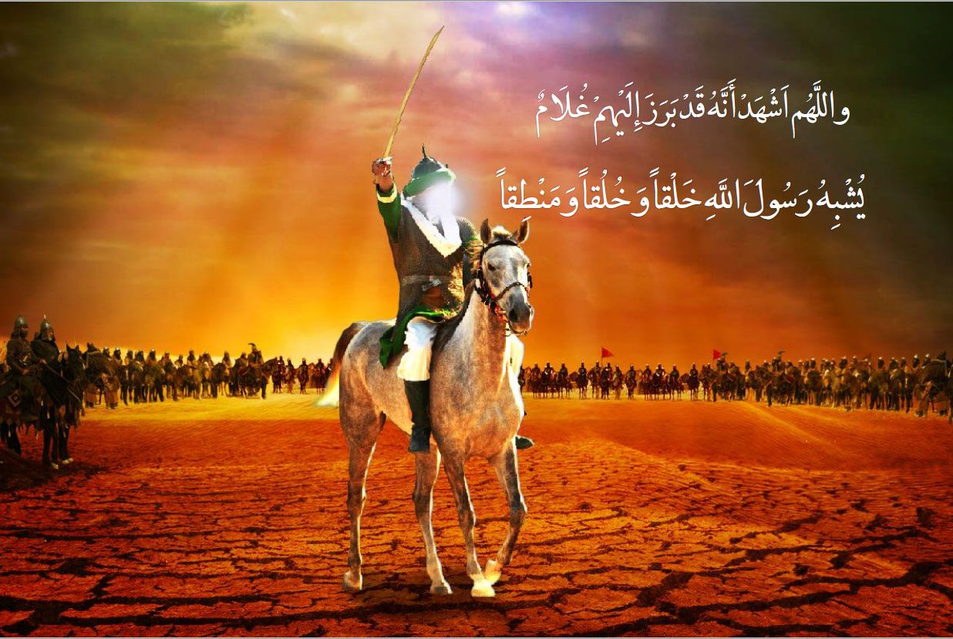

Martyrdom of Qasim ibn Hassan (as)
Qasim ibn Hassan (as) resolved to go to the battlefield, while he was a lad who had not yet come of age. When Imam Hussain (as) saw that Qasim is prepared to step into the attlefield, he embraced him and they wept until both of them fainted. Then Qasim asked permission to go, but Imam refused to grant him the permission. He continuously kissed the hands and feet of Imam Hussain (as) and beseeched Imam (as) to grant him the permission until he permitted him. Tears were flowing down on his cheeks when he was proceeding towards the battlefield and he was reciting the following Rajaz verses: “If you do not know me I am the son of Hasan, the grandson of the Prophet, the chosen one, the confidant and the trustworthy, this is Hussain (as) similar to the one captivated by the mortgager, in the midst of the people who may Allah deprive them of rain water. Verily I am Qasim from the progeny of Ali. By the Lord of the House! We possess superiority while being related to the Prophet (S) than Shimr ibn Dhil Jawshan and the son of an illegitimate one (Ubaydullah ibn Ziyad)”. Amr ibn Sa’d Nufail attacked toward Qasim (as) and struck his head with his sword and Qasim (as) fell face downwards and called out: ‘O uncle!’ Imam Hussain (as) showed himself just like the hawk and struck Amr with his sword and killed him. Imam (as) sat at the head of Qasim (as) and said: Far be [from the mercy of Allah] the people who have killed you, a people against whom your grandfather will complain on the Day of Judgement. By Allah, it is hard for your uncle that you called him but he could not answer you, or he answered but it could not benefit you. Then Imam (as) carried Qasim to the tents and placed his body next to the bodies of other martyrs and said, “Forbear O dear cousins! Forbear O my household! After today you shall never ever see humiliation”.

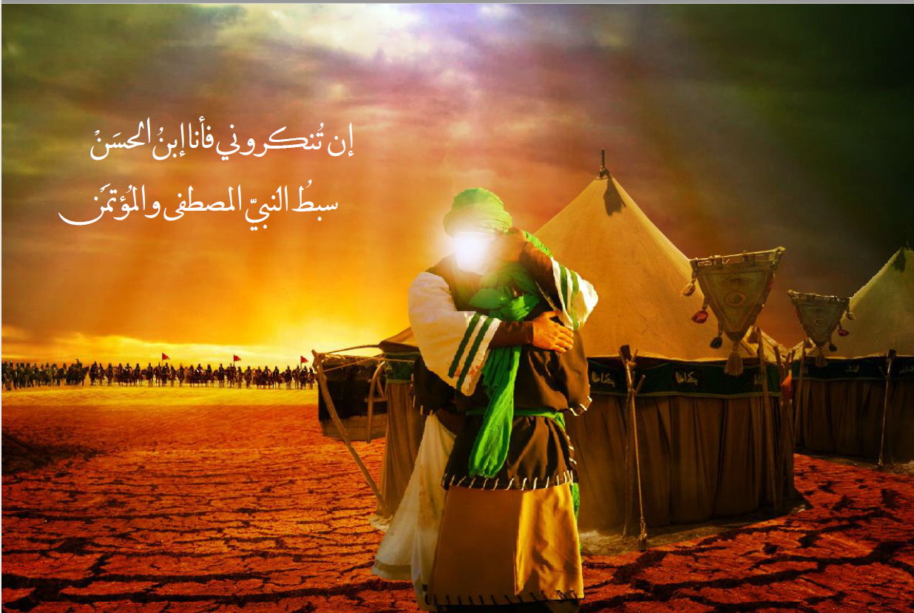

Imam Hussain (as) with the Moon of Bani Hashim Go toward Euphrates
One of the prominent personalities who had a determining role in Ashura and created perpetual scenes of loyalty and sacrifice in the way of the Hujjat of God is Hazrat Abbas ibn Ali (as). His obedience and loyalty to Imam Hussain (as), has introduced him as a hero in history. After the martyrdom of Imam’s companions and the Ahlul Bayt’s intense need to water, Imam (as) and his brother, Abbas (as), resolved to provide some water. They entered the battlefield and galloped towards the Euphrates. When Imam (as) moved toward the Euphrates, the army of Umar ibn Sa’d obstructed his way. In this situation, the enemy’s army surrounded Abbas (AS) from all sides and separated him from Imam Hussain (as). Abbas (as) fought with them lonely while he was reciting this Rajaz: “I swear by the Almighty and Sublime Allah and I swear by Hajoon and Zamzam, I swear by Allah the Lord of Hatim (a part of Ka’ba’s wall) and the sacred door [of Ka’ba], today, my body will be colored with my blood at the presence of a man of integrity and honor, I mean Hussain (as) who owns many honors.” When Hazrat Abbas (as) was going to bring some water recited the following Rajaz verses, “When the bird of death calls, I have no fear of the death until I immerge into an ocean of adroit and spry men. May my soul be sacrified for the pure chosen one [Hussain (as)]. I am Abbas and every morning my job is to serve water. When I face the evil, I won’t be afraid of it.” Then he attacked the enemy and scattered their crowd.

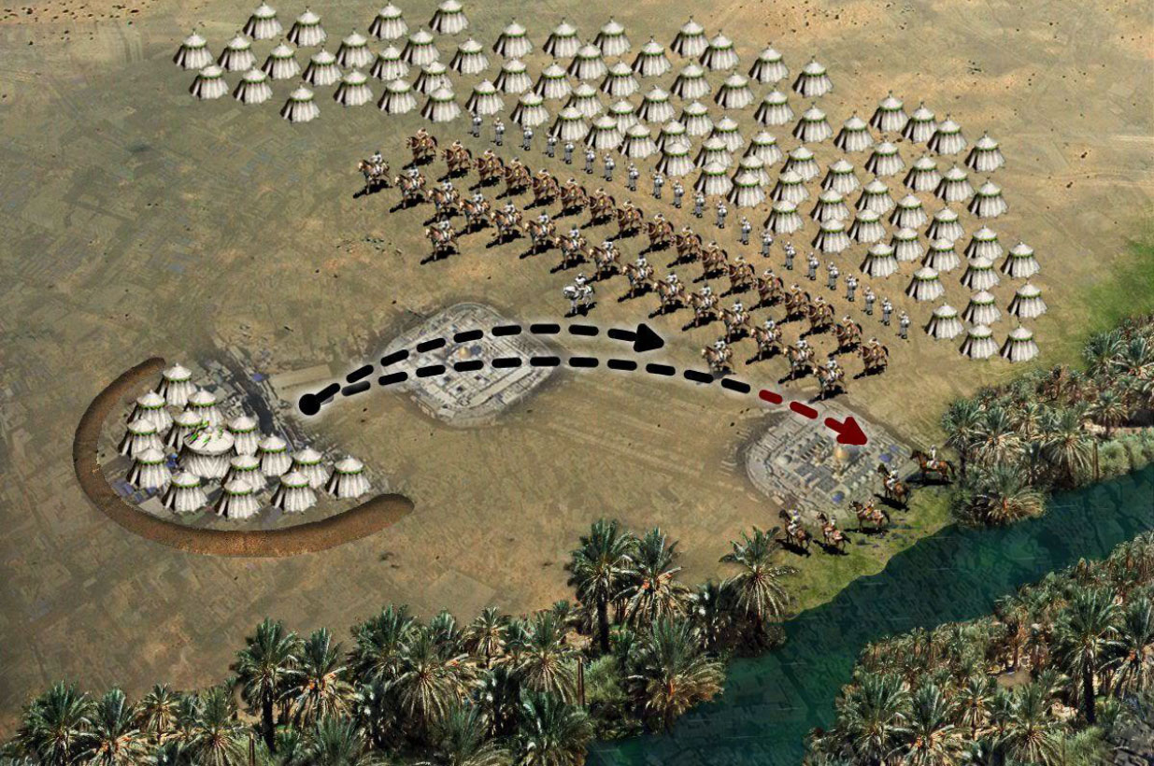

The Fight and the Martyrdom of Abbas (as)
At this moment, Zayd Ibn Warqa Juhani who was lurking behind a palm tree struck a sword blow to his right arm. Abbas (as) took the sword in his left hand and attacked them while reciting the following Rajaz:
By Allah! If you cut off my right hand,
I shall not cease defending my creed, And an Imam true to his conviction do I defend, a son of the trustworthy Prophet whom Allah did send.
Abbas (as) kept fighting until Hakim ibn Tufail Ta’i struck him with his sword on his left hand, severing it, too. Abbas (as) said loudly, “O soul, don’t be dreadful of the infidels and have the good tidings of receiving the Allah’s mercy by keeping the side and company of the Prophet, the Allah’s chosen. Then that cursed person (Hakim ibn Tufail) hit him with a metal pole on his head, causing his martyrdom. And this happened when Abbas got injured by several serious wounds [because of arrows, swords and other blows]. When Imam Hussain (as) saw Abbas lying on the ground near the Euphrates, cried hard for his martyrdom. And [brokenheartedly] said: “Now my spine is split and my endeavour is further weakened.” Then Imam (as) said: O the worst of the people, with this work you transgressed and opposed the order of God’s Messenger, Muhammad (sawa). Did the best of the Prophets not advise you [to be careful] about us? With the crime you commited you are afflicted by humiliation and God’s curse and you will be burned in the hellfire.

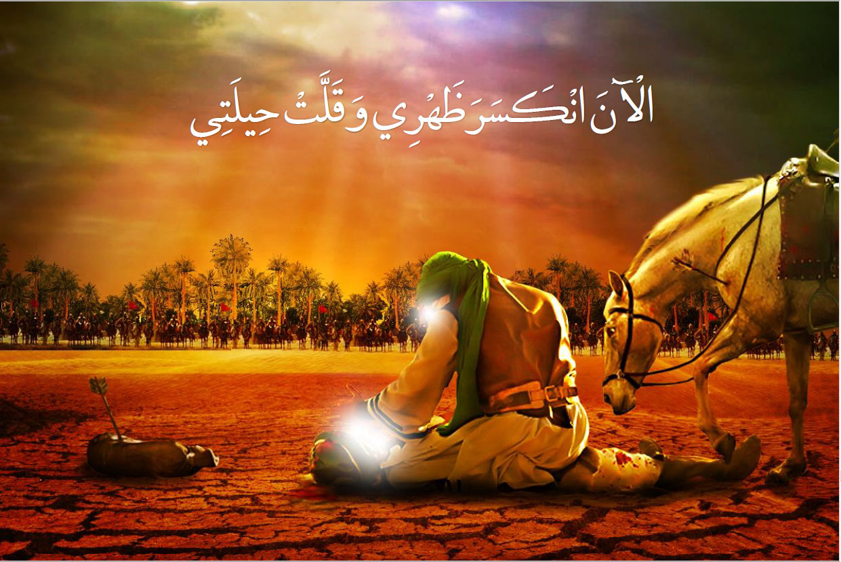

The fight and the martyrdom of Imam Hussain (as)
The martyrdom of Imam Hussain (as) the leader of the cause of Karbala is the culmination of grief at this heart-rending event. Before advancing toward the battlefield, Imam Hussain (as) handed the last wills and the legacy of the Prophet (S) over to the next Imam, i.e. Zain alAbideen (as). He then said, “O my dear son, insist on the truth [and be steadfast on the right path] even if it is bitter”. He also said, “O my dear son, abstain from oppressing someone who has no helper and supporter other than God.”
Then after wearing a thawb (garment) which he had torn several parts of it, bade farewell to the women (of Ahl al-Bayt). Then he went toward the enemy’s army, faced them and delivered a sermon:

Woe be to you O the people of Kufa! Ugly be you and your work! You enthusiastically invited us to assist you, and we hastened to do so. Then now you have unsheathed those very swords, which you had taken to defend us with, and you have kindled the fire for us which we ourselves had kindled for your enemies and ours. Then Imam (as) called out: Is there anyone to defend the family of the Messenger of Allah? At that time, the voice of lamenting ladies arose and Imam (as) came to the door of the tent and called for Zainab (sa) saying, “Give me my infant child (Ali Asghar) so that I may bid him farewell”.

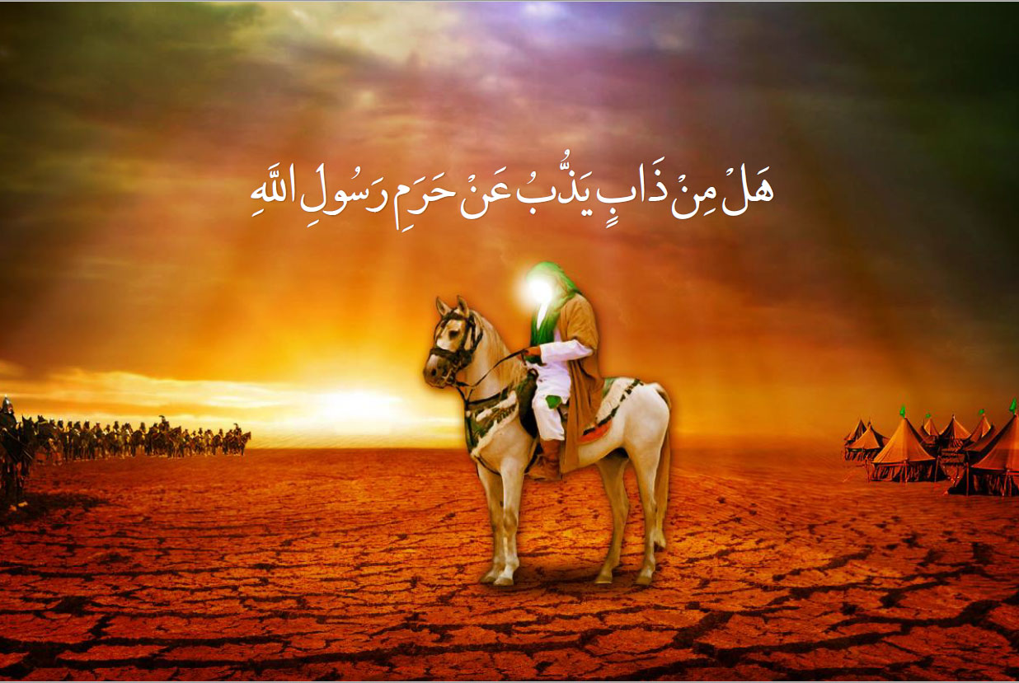

The Martyrdom of the Infant of Imam Hussain (as)
Imam (as) placed him in his lap and kept kissing him and repeating this statement: “Woe be to these people when your grandfather, the chosen one [the Prophet] (S), is their opponent.”
While the baby was at the lap of his eminence (as), Harmala bin Kahil Asadi shot an arrow at the child and martyred him in his father’s lap.
His holiness (as) filled his palm with the child’s blood and threw it towards the heavens saying, “Every hardship is easy upon me when Allah is the Beholder”. Then Imam (as) said:
“O Allah! Be a judge between us and those who invited us, having promised assistance, and in return killed us”.
Imam Baqer (as) said, “Not a drop of that blood came down to the earth”.
Then Imam Hussain (as) dug a grave for the infant using his sword’s sheath and rubbed the blood on the child’s whole body and buried him.

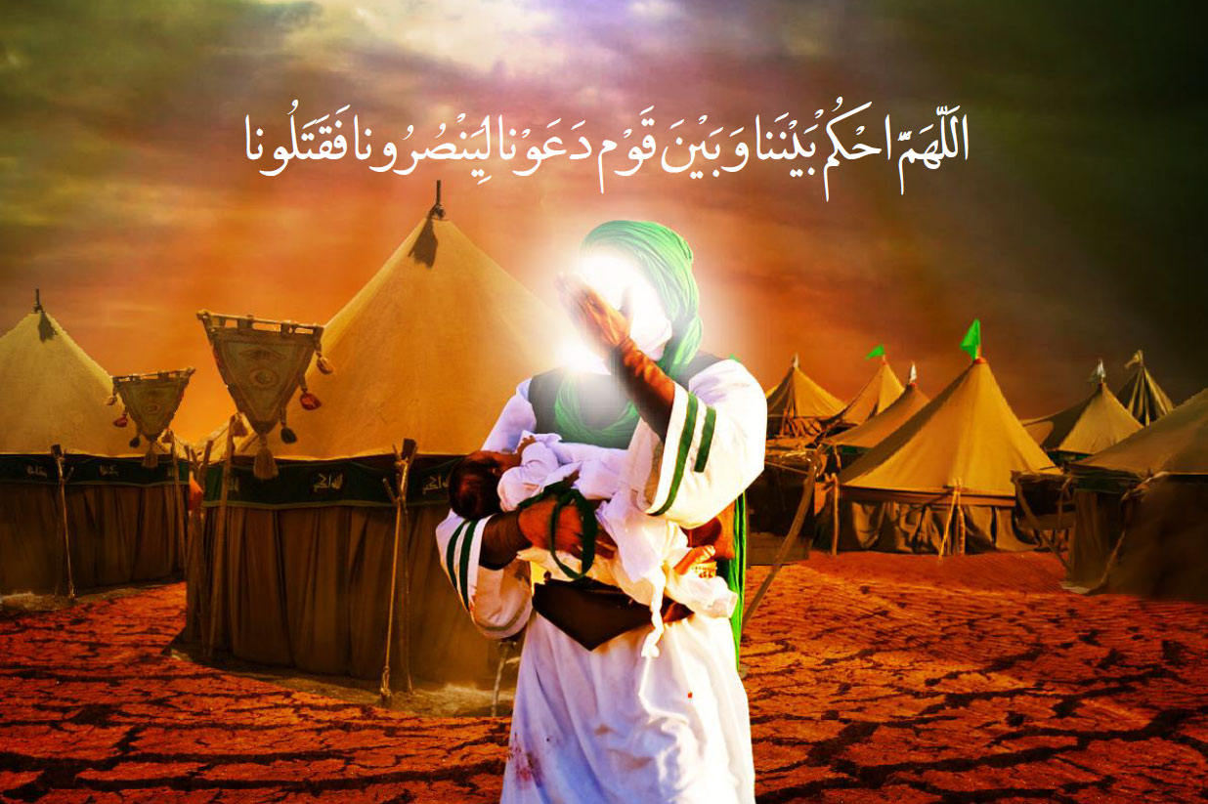

Imam (as) Starts the Battle and Asks for Help
[After burying his infant,] Imam Hussain (as) stood up and mounted his horse and stood against those people and delivered a sermon and while having his sword at hand and having the resolution to go for martyrdom, said: “I am the son of Ali, the chaste from the progeny of Hashim, and this honor is enough for me whenever I pride myself. My grandfather is the Messenger of Allah (sawa) the most eminent among all and we are the lanterns of Allah among the creatures. My mother is Fatimah Zahra (sa), the daughter of Ahmad (sawa), and my uncle Ja’far is known as the possessor of two wings [in the heaven], and we are the trusts of Allah among all men, while we declare this in secret and in the open that we possess authority upon the spring (of Kawthar) and we shall feed our followers with the cup of the Prophet, which cannot be denied, and our followers are the best among followers, while the one who bears animosity towards us shall be doomed and harmed on the day of Qiyamah”.
Then Imam (as) called the army for combat and whoever came close to him was killed instantly until he piled up the corpses. He kept fighting until they barred between Imam (as) and his tents and went toward Imam’s tents. Imam (as) shouted at them loudly,

“Woe be to you O followers of the family of Abu Sufyan! Then if you don’t have any religion and do not fear the day of resurrection, at least be freemen and noblemen in your world”.

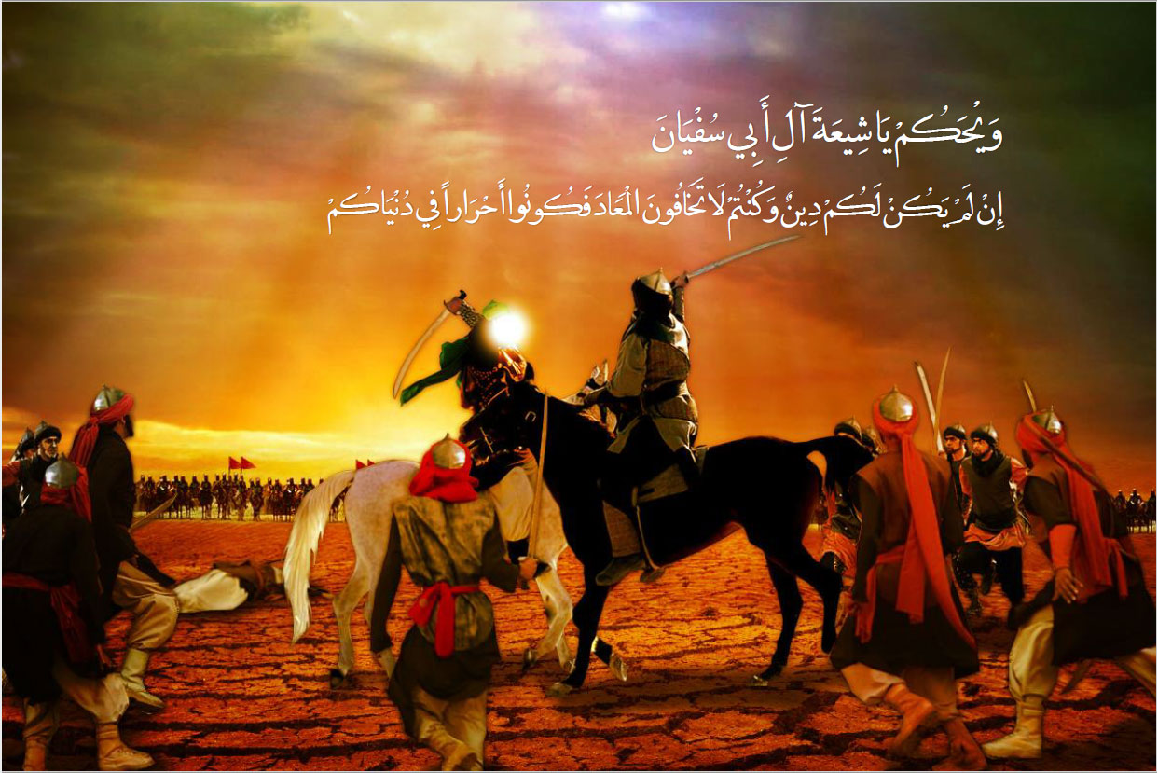

Martyrdom of Abdullah ibn Hassan (as)
Abdullah ibn Hassan (as) who was a lad who had not yet come of age ran out of the tent before the women. Zainab (sa) reached herself to him in order to refrain him from going. Imam Hussain (as) told his sister to keep him. Abdullah didn’t bear it and seriously insisted to go and said, “By Allah! I won’t leave my uncle”. Abjar ibn Ka’b advanced toward Imam Hussain (as) with his sword. That young child [Abdullah] said, “O the corrupt person, are you going to kill my uncle?” Abjar dealt a blow from his sword [toward Imam Hussain (as)] and Adullah took his hand in front of the blow and his hand was cut off and hung from the skin. The child cried in agony, “O mother!” Imam Hussain (as) embraced him and said, “O son of my brother!
Be patient with regard to what has befallen us, and consider it as goodness from Allah; for Allah, the most Exalted, will make you join your righteous ancestors, the Messenger of Allah (S), Ali ibn Abi Talib (as), Hamzah, Ja’far and Hassan ibn Ali (as)”.
Then Imam Hussain (as) raised his hands toward the heavens in supplication and said, “O Lord! Hold back the rains of the heavens and the abundance of the earth from them. O Lord! Then if you let them enjoy themselves for some time, divide them and make them into parties, then make the rulers to be ever displeased with them. For they invited us to render assistance and then rebelled against us, oppressed us and killed us”.

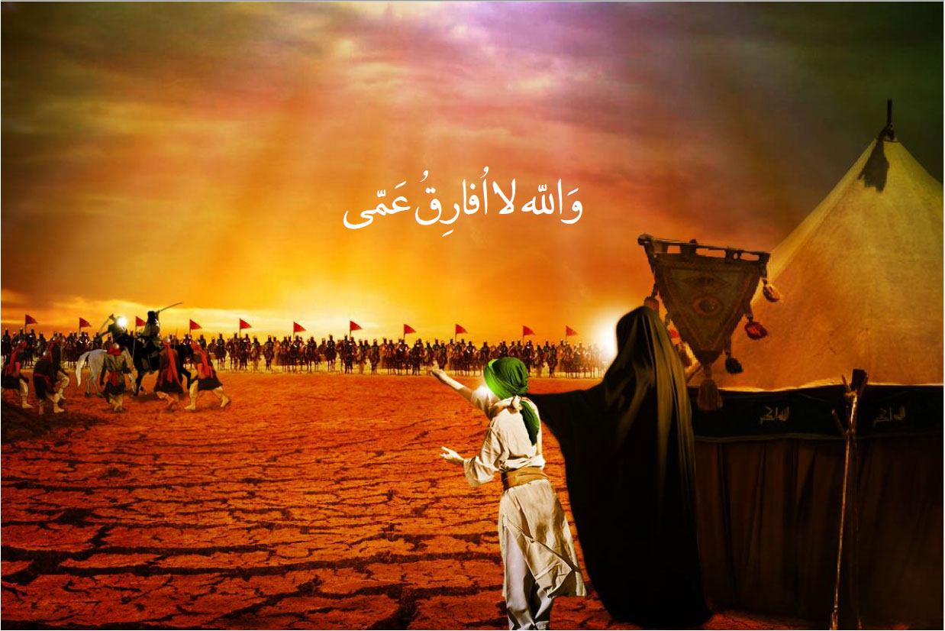

Martyrdom of Imam Hussain (as)
Imam Hussain (as) kept fighting them until his pure and blessed body was injured tens of times and while having become too weak to fight, he stood to take a rest. It was then that a man threw a stone at him, hitting his forehead and causing his blood to run down his face. He took his shirt to wipe his blood from his eyes just as another man shot him with a threepronged arrow that pierced his chest and settled in his heart. Imam Hussain (as) instantly said, “In the Name of Allah and by Allah, and on the creed of the Messenger of Allah (S)”. Then he raised his head to the heavens and said, “O Lord! You know that they have resolved to kill the one besides whom there is no other son of the Prophet upon this earth!” Then he took and pulled the arrow from his back and a lot of blood started gushing out and flowing down similar to a groove. He placed his hand on his wound and once his hand was filled with blood, he threw it towards the heavens, and not a single drop of it fell back.
Then he put his hand on the wound a second time and it was again filled with blood. This time he rubbed it on his face and beard and said, “By Allah! Thus I will appear when I meet my Lord and my grandfather, the Messenger of Allah (S), dyed in this blood of mine. O Allah! Do you see the way the son of your Prophet is treated…?”

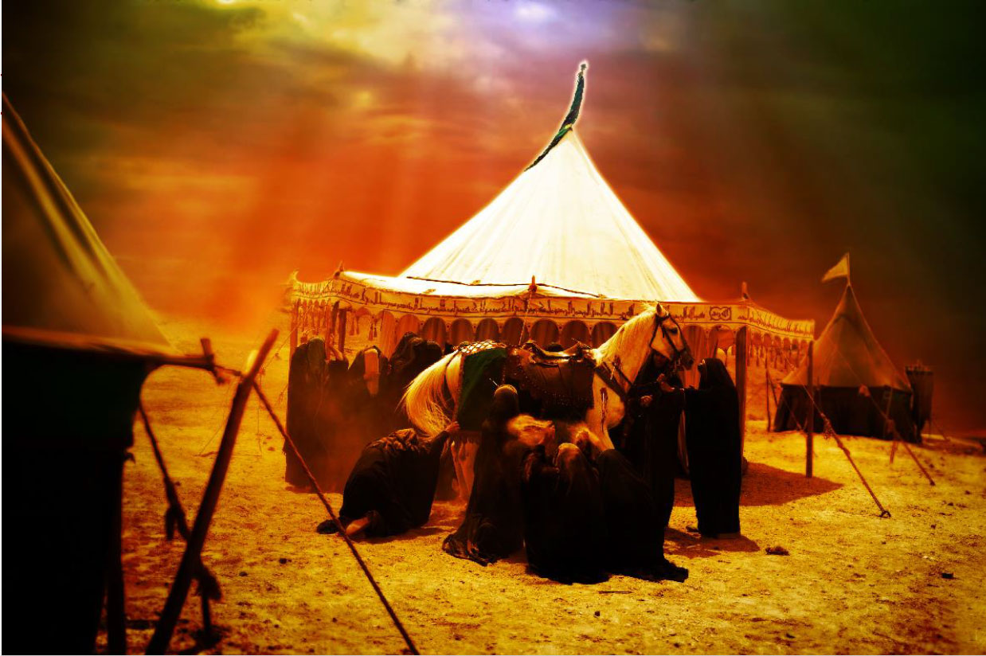

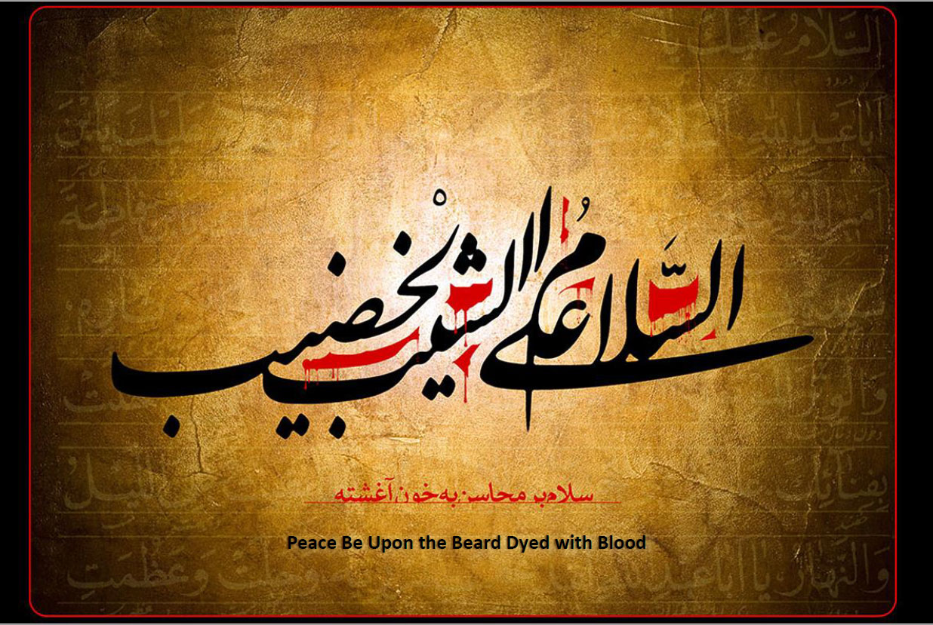

www.alhassanain.org/english

